
Aga Khan Rural Support Program (AKRSP)
REQUEST FOR QUOTATION (RFQ)

RFQ No: AKRSP/0441/2026 Delivery Point: Dizg Upper Chitral
RFQ Date: September 23, 2026, Submission Date: October 06, 2026

Subject: Request For Quotation – Supply & Transportation Of Bridge Materials At Shuist Yarkhoon Valley, Upper Chitral
Introduction
The Aga Khan Rural Support Programme (AKRSP) invites sealed quotations from eligible, qualified and experienced suppliers/firms for the Supply and Transportation of Bridge Materials at Shuist Yarkhoon Valley, Upper Chitral.
The scope of this RFQ covers the supply, packing, loading, transportation, unloading and delivery of the materials listed in the BOQ to the designated project location at Shuist Yarkhoon Valley, Upper Chitral.
All materials shall be brand new, unused, free from defects and strictly in accordance with the specifications stated in this RFQ/BOQ.
The procurement includes structural steel sections, steel wire ropes, GI pipes and fittings, MS plates and checkered sheets, nuts and bolts, U-bolts, bulldog grips, thimbles, clamps and other bridge-related materials as specified below.

TECHNICAL EVALUATION – PASS/FAIL
Only bidders who meet the required technical requirements will proceed to financial evaluation.

Relevant Experience

The bidder must demonstrate relevant experience and sufficient technical, financial, and commercial capacity to successfully execute the required supply and transportation assignment.

The bidder shall have successfully completed at least two (2) similar supply and transportation contracts involving structural steel, bridge materials, steel wire ropes, GI materials, steel sections, construction materials, or other similar items, with a total cumulative contract value of approximately PKR 8 million. The cumulative value may be achieved through one or more completed contracts, provided that the bidder can demonstrate at least two (2) similar completed contracts.

The bidder shall submit supporting documentary evidence, including, but not limited to, Purchase Orders/ Contract Agreements/ Completion Certificates/ Delivery Challans, or Client Acceptance Certificates. The submitted documents must clearly indicate the nature and scope of supply, contract value, completion status, client name, and client contact details for verification.

AKRSP reserves the right to verify the authenticity and accuracy of the information and documents submitted by the bidder with the respective clients or other relevant sources. Failure to provide satisfactory evidence of at least two (2) similar successfully completed contracts, with a cumulative value of approximately PKR 8 million, may result in disqualification.

FINANCIAL CAPACITY

The bidder shall demonstrate adequate financial capacity to undertake the procurement and transportation assignment. The bidder's annual turnover for each of the last two financial years shall be at least PKR 5 million.

The bidder’s stated financial capacity shall be substantiated by providing true copies of its audited financial statements. AKRSP reserves the right to request additional financial information or supporting documentation, as deemed necessary, to assess and verify the bidder’s financial capacity and ability to successfully perform the contract.

Financial Evaluation and Award
Only bidders who are found technically qualified and responsive shall proceed to financial evaluation. The contract shall be considered for award to the lowest evaluated responsive bidder, subject to compliance with all requirements of the RFQ and AKRSP’s procurement procedures.
BOQ – DESCRIPTION OF WORKS
Description of Works: Supply & Transportation of Bridge Materials at Shuist Yarkhoon Valley, Upper Chitral
S. No. | Description of Goods | Specifications | Unit | Qty | Unit Rate (Rs.) | Amount (Rs.)
1 | Steel Wire Rope | 1" diameter, IWRC (6×19), EIPS, galvanized, new. Approximate weight: 0.839 kg/ft. Minimum breaking load: 93,000 lb (approximately 42.2 metric tonnes / 413 kN). | Ft | 914
2 | Steel Wire Rope | 3/8" diameter, IWRC (6×19), EIPS, galvanized, new. Approximate weight: 0.118 kg/ft. Minimum breaking load: 15,100 lb (approximately 6.85 metric tonnes / 67.2 kN). | Ft | 806
3 | Steel Wire Rope | 3/4" diameter, IWRC (6×19), EIPS, galvanized, new. Approximate weight: 0.472 kg/ft. Minimum breaking load: 58,800 lb (approximately 26.67 metric tonnes / 261.5 kN). | Ft | 702
4 | Steel Girder (I-Section) | Size: 8" × 4"; 26 Nos.; length of each girder: 12 ft; web thickness: 6 mm; flange thickness: 8 mm; approximate weight: 7 kg/ft; structural steel ASTM A36 or equivalent, ungalvanized. | Kg | 2,184
5 | MS H-Section | Size: 6" × 6"; L=136 ft; Nos.=8; web thickness: 6 mm; flange thickness: 6 mm; approximate weight: 6.4 kg/ft; structural steel ASTM A36 / IS 2062 Gr. A or equivalent, ungalvanized. | Kg | 7,072
6 | MS C-Section Type-2 | Size: 5" × 2.5"; 52 Nos., each 4 ft long; web thickness: 6 mm; flange thickness: 7 mm; approximate weight: 3.525 kg/ft; structural steel ASTM A36 or equivalent, ungalvanized. | Kg | 728
7 | MS C-Section Type-3 | Size: 4" × 2"; 52 Nos.; length of each section: 4 ft; web thickness: 6 mm; flange thickness: 7 mm; approximate weight: 3 kg/ft; structural steel ASTM A36 or equivalent, ungalvanized. | Kg | 624
8 | MS Checkered Sheet | L=126 ft; Width=8 ft; Thickness=6 mm; Tear-Drop or Diamond Pattern; unit weight approximately 4.83 kg/sq. ft. | Kg | 4,869
9 | MS Plate | Plate thickness: 4 mm; No. of plates=112; Size: 5 in × 10 in. | Kg | 113
10 | G.I. Pipe | 2" nominal diameter, Medium Class, hot-dip galvanized steel pipe, each 20 ft long; wall thickness: 3.6 mm; approximate weight: 1.53 kg/ft. | Ft | 520
11 | G.I. Socket | 2" GI threaded equal socket/coupling, heavy-duty, hot-dip galvanized, female threaded at both ends, suitable for 2" Medium Class GI pipe; BSP pipe thread. | No. | 27
12 | ½" Dia. Nut Bolts | Nut bolts used for transoms; bolt length=3"; diameter=½". | Kg | 228
13 | ½" Dia. U-Bolt | U-Bolts for slings/suspenders, 52 Nos.; ½" diameter; length on each side 14"; total length including rounded bottom approximately 30"; approximately 1.0 kg/bolt including washers. | Kg | 52
14 | Clamp Set | Clamps for holding main wire ropes together; 52 Nos.; clamp diameter 4½"; fabricated from 4 mm thick plate, 4" wide; includes 5/8" diameter × 3½" long nut bolt; approximate weight 1.5 kg/clamp set. | Kg | 78
15 | Bulldog Grips | Heavy-Duty Bulldog Grip, 28 mm, suitable for 26 mm galvanized steel wire rope, with forged steel U-bolt and saddle/base, complete with nuts and washers, hot-dip galvanized, BS EN 13411-5 / FF-C-450 Type 1 Class 1 / ASME B30.26 or equivalent, from a recognized manufacturer with size and identification markings. | Nos. | 58
16 | Bulldog Grips | Heavy-Duty Bulldog Grip, 20 mm, suitable for 19 mm galvanized steel wire rope, with forged steel U-bolt and saddle/base, complete with nuts and washers, hot-dip galvanized, BS EN 13411-5 / FF-C-450 Type 1 Class 1 / ASME B30.26 or equivalent, from a recognized manufacturer with size and identification markings. | Nos. | 312
17 | Bulldog Grips | Heavy-Duty Bulldog Grip, 10 mm, suitable for 9 mm galvanized steel wire rope, with forged steel U-bolt and saddle/base, complete with nuts and washers, hot-dip galvanized, BS EN 13411-5 / FF-C-450 Type 1 Class 1 / ASME B30.26 or equivalent, from a recognized manufacturer with size and identification markings. | Nos. | 208
18 | Thimbles | Hot-Dipped Galvanized Steel Thimbles, 19 mm (Suspender). | Nos. | 108
19 | G.I. Saddle Clamp | Saddle clamp manufactured from 3 mm thick galvanized iron sheet, 1" wide, formed to suit a 2" GI pipe with an internal diameter of approximately 2.25"; provided with two ½" diameter mounting holes; complete with galvanized nuts, bolts and washers. | Nos. | 104
20 | Transportation Cost | Transportation to Shuist Village, approximately 145 km from Chitral Town. Cost shall include transportation, loading and unloading charges and all incidental costs required for delivery to the designated location. | LS | 1
 |  | TOTAL COST INCLUSIVE OF ALL TAXES
Total Cost (PKR): ______________________________
Amount in Words: ___________________________________________________________
Note: The quantities mentioned above are approximate and may vary depending on actual site requirements/conditions. Any variation shall be subject to AKRSP's approval.
BID SECURITY
Bid Security Requirement
Each bidder shall submit a Bid Security equivalent to 2.5% of the total bid value along with its quotation.
The Bid Security is intended to demonstrate the bidder's commitment to its offer and to protect AKRSP against the risk of a bidder withdrawing or modifying its quotation during the bid validity period or failing to comply with the conditions applicable to award.
Acceptable Forms of Bid Security
The Bid Security shall be submitted in any one of the following forms:
- Bank Guarantee issued by a scheduled bank operating in Pakistan;
- Call Deposit Receipt (CDR);
- Pay Order;
- Demand Draft; or
- Banker's Cheque.
The Bid Security shall be made payable in favour of Aga Khan Rural Support Programme (AKRSP) and shall be submitted together with the quotation.

Validity of Bid Security
The Bid Security shall remain valid for at least twenty-eight (28) calendar days beyond the bid validity period.
Submission and Verification
The original Bid Security shall be submitted with the sealed quotation.
AKRSP reserves the right to verify the authenticity and validity of the Bid Security with the issuing bank or financial institution.
Any Bid Security that is found to be forged, invalid, expired, insufficient in amount, incorrectly issued or otherwise not in compliance with the RFQ requirements may result in the bid being declared non-responsive.
Failure to Submit Bid Security
A bid submitted without the required Bid Security, or with Bid Security for an amount less than 2.5% of the total quoted bid value, may be considered non-responsive and rejected without further evaluation.
Similarly, a Bid Security that does not meet the prescribed form, validity, beneficiary or other mandatory requirements may result in rejection of the bid.
Return of Bid Security
The Bid Security of unsuccessful bidders shall be returned after completion of the evaluation process and award of the contract, subject to AKRSP's procurement procedures.
The Bid Security of the successful bidder shall be returned upon successful completion of all supply and transportation obligations and satisfactory inspection and verification by AKRSP.
Forfeiture of Bid Security
AKRSP may forfeit the Bid Security if the bidder:
- Withdraws or modifies its quotation during the bid validity period;
- Refuses to accept the award after being selected;
- Fails to sign the contract or Purchase Order within the period specified by AKRSP;
- Fails to provide any required contractual security or documentation after award;
- Provides false, forged, fraudulent or materially misleading information; or
- Engages in corrupt, collusive, fraudulent, coercive or obstructive practices during the procurement process.
No Interest
No interest, profit or other financial compensation shall be payable by AKRSP on the Bid Security, irrespective of the form in which it is submitted.
PAYMENT TERMS
Payment shall be made through crossed cheque or bank transfer within fourteen (14) working days after achievement of the applicable milestone, satisfactory inspection/verification by AKRSP and submission of required documents.
First Payment – 75%
Seventy five percent (75%) of the total contract value shall be paid upon delivery of the materials to Chitral, subject to satisfactory inspection and verification by AKRSP, confirmation of the required quantities and specifications, and submission of the original invoice, delivery challan and all relevant supporting documents.
Second Payment – 25%
The remaining twenty five percent (25%) of the total contract value shall be paid upon successful delivery of all materials to Shuist Yarkhoon Valley, Upper Chitral, subject to satisfactory verification by AKRSP, confirmation that all materials have been delivered in the required quantities and are free from transit damage, and submission of the final delivery documentation and invoice.
No advance payment shall be made.
All payments shall be made only after completion and verification of the respective delivery milestones by AKRSP.
Applicable withholding taxes and other statutory deductions shall be deducted at source from the payable amount in accordance with the prevailing laws of Pakistan.
INSPECTION AND QUALITY CONTROL
All materials supplied under this RFQ shall be brand new, unused and free from any defects.
AKRSP reserves the right to inspect and verify the materials before dispatch, during transportation and upon delivery.
The supplier shall provide relevant:
- Manufacturer's certificates;
- Material test certificates;
- Test reports;
- Certificates of conformity; and
- Other quality documents,
where applicable.
Any material found to be defective or not in compliance with the specified technical requirements may be rejected by AKRSP and shall be replaced by the supplier at its own cost, including all transportation and handling expenses.
Inspection, verification or payment by AKRSP shall not relieve the supplier of its responsibility for any latent defects, non-conformities or quality issues identified subsequently.
TAXES AND STATUTORY REQUIREMENTS
All quoted rates shall be inclusive of all applicable federal and provincial taxes, duties, levies, fees, transportation charges, loading and unloading costs and other statutory or incidental charges payable under the prevailing laws of the Government of Pakistan and the relevant Provincial Government.
The supplier shall be responsible for ensuring that its quoted prices fully account for all applicable tax and statutory obligations related to the supply and transportation of the materials.
The supplier shall provide valid NTN, sales tax registration details, KPRA registration where applicable, tax invoices, receipts, delivery challans and any other documents required for compliance with applicable federal and provincial tax laws and regulations.
AKRSP shall deduct Withholding Tax (WHT), Sales Tax, KPRA tax or any other applicable statutory deductions from payments, where required by the prevailing laws of Pakistan and the relevant provincial tax authorities, and shall deposit such deductions with the concerned government authority as required by law.
Relevant tax deduction certificates shall be provided to the supplier where applicable.
The supplier shall be solely responsible for the accuracy and validity of all tax-related information and documents submitted to AKRSP. Any additional tax liability, penalty, interest, fine or other financial obligation arising due to incorrect, incomplete, invalid or misleading information provided by the supplier shall remain the supplier's responsibility and shall not be payable by AKRSP.
TRANSPORTATION, SAFETY AND LIABILITY
The supplier shall use suitable and roadworthy vehicles and shall ensure proper loading, securing, transportation and unloading of all materials.
The supplier shall comply with applicable traffic, transportation, health and safety requirements.
Any loss, damage, accident or injury arising from the supplier's transportation or handling activities shall remain the supplier's responsibility.
The supplier shall maintain appropriate insurance for its personnel, vehicles, goods and third-party liabilities, as applicable.
The supplier shall ensure that all steel sections, wire ropes, sheets, pipes and other materials are adequately secured during transportation to prevent damage, loss or deterioration.

ANTI-FRAUD, ANTI-COLLUSION AND CONFLICT OF INTEREST
AKRSP maintains zero tolerance for fraud, corruption, collusion, bid-rigging and other prohibited practices.
The bidder shall provide complete, accurate and genuine information and shall conduct the bidding process in a fair and transparent manner.
AKRSP reserves the right to reject a quotation, disqualify a bidder or terminate the contract if the bidder:
- Submits false, forged, misleading or fraudulent information;
- Engages in collusion or bid-rigging;
- Attempts to improperly influence the evaluation or award process;
- Has any undisclosed actual or potential conflict of interest; or
- Engages in corrupt, fraudulent, coercive or obstructive practices.

Any such action may also result in forfeiture of bid security and/or other remedies available to AKRSP under the applicable procurement rules and contract.
DISQUALIFICATION
A quotation may be rejected or declared non-responsive if it:
- Is submitted after the deadline;
- Is incomplete, unsigned or unstamped;
- Does not include the required Bid Security;
- Fails to meet mandatory technical specifications;
- Does not provide required evidence of relevant experience;
- Contains unauthorized conditions or deviations;
- Contains false, forged or misleading information;
- Does not comply with the required quotation validity period; or
- Fails to meet any other mandatory requirement of this RFQ.

AKRSP'S RIGHTS
AKRSP reserves the right, in accordance with its applicable procurement policies, to:
- Accept or reject any or all quotations without assigning a reason;
- Cancel, suspend or re-advertise the procurement process;
- Seek clarification from bidders;
- Verify any information, documents, references or claims submitted by bidders;
- Inspect materials before and after delivery;
- Reject materials that do not comply with the required specifications; and
- Award the contract to the bidder whose quotation is determined to be substantially responsive and provides value for money, taking into consideration price, technical compliance, quality, experience and capacity to deliver.

CONTRACTOR'S ACCOMMODATION, TRAVEL AND SUBSISTENCE
The contractor shall be solely responsible for arranging and bearing all costs related to accommodation, meals, travel, local transportation, fuel, communication and other logistical requirements for its personnel throughout the execution of the contract.
AKRSP shall not provide or reimburse any such expenses, including accommodation, food, travel, transportation, lodging or other incidental costs, unless expressly agreed and stated in writing in the contract.
FORCE MAJEURE AND GOVERNING LAW
Neither party shall be liable for failure or delay caused by events beyond its reasonable control, including natural disasters, war, civil unrest, government restrictions or other force majeure events.
The contract shall be governed by the laws of the Islamic Republic of Pakistan.
Disputes shall first be resolved amicably through consultation; failing such resolution, the matter may be referred to the competent courts having jurisdiction in Chitral.
SUBMISSION DEADLINE
Sealed quotation should be submitted by hand or through courier at Regional Office AKRSP near Shahi Qilla Chitral by COB October 06, 2026
Quotations received after the specified deadline shall not be opened and shall be returned unopened where practicable.

Admin & Procurement Officer
AKRSP Chitral

BIDDER'S DECLARATION
By submitting a quotation, the bidder confirms that it has carefully read, examined and understood the complete RFQ document, including the scope of supply and transportation, BOQ, technical specifications, delivery requirements, payment terms, bid security requirements, evaluation criteria, taxes and all other terms and conditions.
The bidder further confirms that the quoted rates are based on a full understanding of the requirements and that the bidder has satisfied itself regarding the nature and extent of the required supply and transportation.
The bidder acknowledges that all information and documents submitted with the quotation are true, accurate, complete and valid, and agrees to comply with all applicable requirements of this RFQ and the prevailing laws and regulations of Pakistan.
By signing below, the bidder confirms its acceptance of the terms and conditions of the RFQ and undertakes to fulfill its contractual obligations if awarded the contract by AKRSP.

VENDOR RECEIPT & ACKNOWLEDGEMENT
I/We hereby acknowledge receipt of the RFQ document and confirm that I/we have read and understood its contents and agree to comply with the requirements, terms and conditions stated therein.
Name of Authorized Representative:
Designation:
Company/Firm Name:
CNIC/NTN (if applicable):
Contact No.:
Email:
Signature & Official Stamp:
Date:
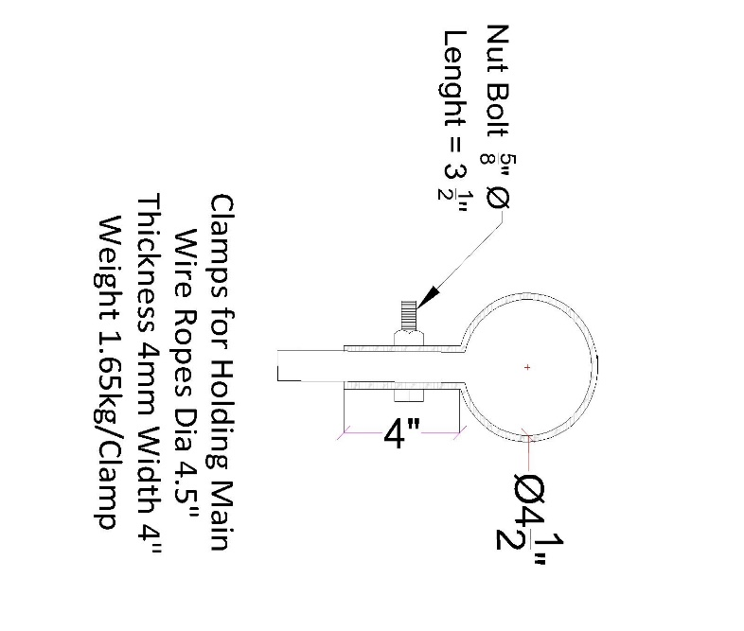
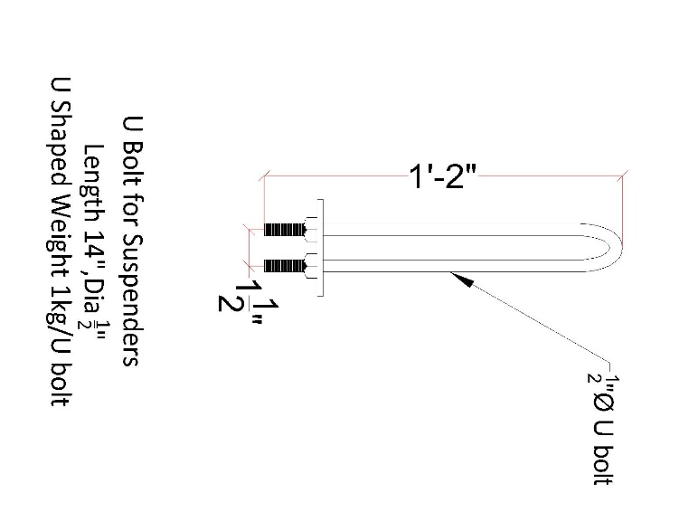

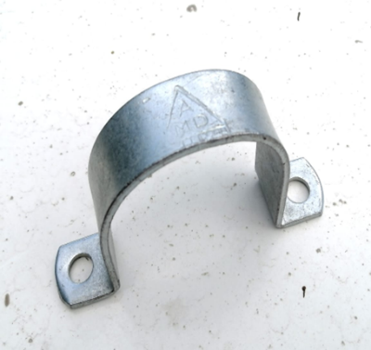
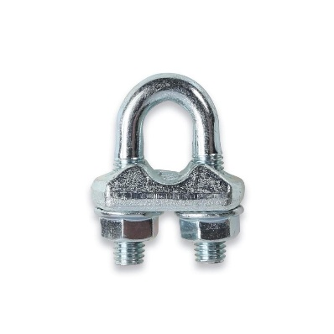
Picture of G.I Saddle Clamp
Bulldog Grip with forged U bolt and Saddle

steel U bolt & Saddle

