

  - Standard Bidding Documents
  - for the construction of

Construction of 300 kW Darkut MHP in Ghizer

Section 0: Invitation to Bid (ITB)

PREFACE
These Standard Bidding Documents (SBDs) for the Procurement of Works have been prepared by the Aga Khan Rural Support Programme (AKRSP) for the procurement of civil works for the Construction of 300 kW Darkut MHP in Ghizer, located in Darkut, District Ghizer, Gilgit-Baltistan.
The procurement process shall be carried out in accordance with the applicable procurement policies, procedures, and guidelines of AKRSP. These Standard Bidding Documents provide the basis for inviting, evaluating, and awarding bids and for the subsequent administration and execution of the Works.
The Standard Bidding Documents are organized into the following parts:
PART 0 – Invitation to Bid
Section 0 General project information for bidders
PART I – Bidding Procedure
Section 1: Instructions to Bidders (ITB)
This Section provides relevant information to help Bidders prepare their bids. Information is also provided on the submission, opening, and evaluation of bids and on the award of Contracts. Section 1 contains provisions that are to be used without modification.
Section 2. Bid Data Sheet (BDS)
This Section includes provisions that are specific to each procurement and supplement Section I, Instructions to Bidders.
Section 3.1: Bidding Forms
This Section includes the standard bidding forms which are to be completed by the Bidder and submitted as part of the Bid.
Section 3.2 Bill of Quantities (BOQs)
This Section includes the BOQs which must be verified and priced by the Bidder and submitted with the financial bid documents.
PART II – AKRSP’s Technical Requirements
Section 4 Detailed Drawings
This Section includes the detailed drawings forming part of the Bidding Documents.
PART III Conditions of Contract and Contract Forms
Section 5 Contract Forms incl. General and Particular Conditions of Contract
This Section contains forms which, once completed, will form part of the Contract. The forms for Performance Security and Advance Payment Security, when required, shall only be completed by the successful Bidder after contract award.
The General Conditions of Contract contain the general clauses to be applied in all contracts. The text of the clauses in this Section must not be modified.
The Particular Conditions consist of Part A ‘Contract Data’, containing general data, and Part B, ‘Specific Provisions’, which contains clauses specific to each contract. The contents of this

Section supplements the General Conditions of Contract and shall be prepared by the AKRSP.
PART 0 – Invitation to Bid
Section 0 General project information for bidders.

Objectives
Project name: Construction of 300 kW Darkut MHP in Ghizer
Location of project: Gamalti Village, Darkut Valley, Union Council Silgan, District Ghizer, Gilgit-Baltistan
Summary of Project:
The proposed 300 kW Darkut Mini Hydel Power Project (MHP) is located at Gamalti Village in Darkut Valley, Union Council Silgan, District Ghizer, Gilgit-Baltistan. The project site is approximately 170 km from Gilgit City and is situated at an elevation of about 8,500 feet above sea level. The project will utilize water from Gamalti Nallah, which is primarily fed by glacier melt and snow-covered mountains in the upper catchment.
At present, Darkut Valley receives electricity from the existing 500 kW Umalsat Mini Hydel Power Plant, constructed by AKRSP and operated by Silgan Electric Limited. Electricity is supplied to Darkut through approximately 3 km of underground transmission line, which was installed due to strong winds along the transmission route that make overhead transmission difficult. Over time, the underground line has deteriorated, resulting in frequent faults, power losses, and prolonged interruptions in electricity supply. Consequently, households, businesses, and community institutions in Darkut Valley continue to experience unreliable and insufficient electricity.
To address these challenges, AKRSP proposes the construction of a dedicated 300 kW Mini Hydel Power Plant at Gamalti. The project aims to improve energy reliability and security by providing clean and efficient electricity to Darkut Valley. It will also reduce the load on the existing Umalsat MHP, enabling more of its available generation capacity to serve downstream communities in Silgan Valley.
The project is expected to support local economic activities and community services, improve the quality of life, and reduce dependence on fuelwood, kerosene, and other conventional energy sources. By increasing access to renewable hydropower, the project will also contribute to reducing environmental degradation and supporting climate change mitigation.
Budget and financing:
Funds for the Construction of 300 kW Darkut MHP in Ghizer are allocated under the Central Asia Poverty Programme (CAPP). AKRSP is responsible for implementation of the project in partnership with local community organizations and other relevant stakeholders.
RELEVANT BACKGROUND INFORMATION

AKRSP and Stakeholders
AKRSP, established in 1982 and registered under the Companies Act in Pakistan as a non-profit company, has been working in Gilgit Baltistan & Chitral (GBC) region of Pakistan with the mandate to improve the quality of life of rural people through an approach rooted in social mobilization and community organization.
AKRSP, with AKF’s supervision, will implement the project in partnership with community organizations and in consultation with other AKDN agencies. The AKRSP technical staff and supervisors will closely monitor construction works to ensure the quality and implementation of the project per the defined specifications. AKRSP will maintain close coordination with District Administration, and other relevant departments to implement this project in a collaborated manner. Local communities will be involved in all stages of project implementation, through their community-based organization. The involvement of communities in all stages of project implementation will ensure transparency and accountability in the process. After completion, the project will be handed over to communities and local administration for routine and upkeep.

Procedure of bidding process
Documents to be submitted are defined in Section 1 - Instructions to Bidders

Deadline for submission date and location for bidding
The deadline and location for submission of the complete bidding documents is mentioned in Section 2, - Bid Data Sheet, paragraph 1.

Minimum Requirements for Bidders
To be successful, a bidder must satisfy the following minimum requirements:
Work Experience: Implemented 03 (three) projects of the same nature and at least PKRs 20 million contract value each in the past 10 years in Gilgit Baltistan. The experience must be supported with orders and completion certificates.
- Financial Capability: The average annual turnover over the last five years shall be at least 25 million which should be supported by original bank statements or audit reports
- Staff Resources: The Bidder must have at least the following the staff:
01 (One) Civil engineer with at least 03 (three) years of professional construction experience.
01(One) sub-engineer who has at least 2 (Two) years of experience in construction

- List of Equipment: The company should own the following equipment.

S# | Particular | Quantity
01 | Excavator | 01
02 | Dumper/Mazda | 02
03 | Mixer Machine | 01
04 | Concrete Vibrator | 01

Evaluation of bids
A Bidder has to submit the information in a sealed envelope as specified in Section 1 and Section 3 of the Bidding Documents The evaluation of bids will be carried out in two steps:
- Technical Qualification: Required information will be evaluated on a ‘pass’ and ‘fail’ basis according to criteria listed in Section 1.
- Financial evaluation: The most favorable bidder is the one with the lowest price and complying with all requirements.

  - Bidding Documents for the

Construction of 300 kW Darkut MHP in Ghizer

Section 1: Instructions to Bidders (ITB)

Content
INSTRUCTIONS TO BIDDERS 1
1 Scope of the Tender 1
2 Conflict of Interest 1
3 Fairness and Transparency 1
4 One Tender per Bidder 2
5 Pre-bid meeting or site visit 2
TENDER DOCUMENTS 3
6 Contents of tender documents 3
7 Clarifications and questions 3
8 Amendment of tender documents 3
PREPARATION OF BIDS 4
9 Language of bid 4
10 Documents comprising the bid 4
11 Tender Prices 6
12 Currencies of Tender and Payment 6
13 Tender Validity 6
14 Alternative Proposals by Bidders 7
15 Format and Signing of Tender 7
16 Neglecting of Bids 7
17 Modification and withdrawal of bids 7
TENDER OPENING AND EVALUATION 9
18 Bid Opening 9
19 Process to be confidential and transparent 9
20 Clarification of bids 9
21 Examination of bids and determination of responsiveness 9
22 Evaluation and comparison of bids 9
23 The AKRSP’s right to accept any tender and to reject any or all bids 10
24 Complaint Mechanism by Bidders 10
AWARD OF CONTRACT 11
25 Award criteria 11
26 Notification of Award 11
27 Signing of Contract Agreement 11
28 Performance Security 11
1 Declaration of Undertaking 1
2 Letter of Submission 1
3 Bidder Information Form 3
4 Work Experience in the last five years 4
5 Financial Capability 18
6 Staff Resources 20
6.1 Presentation of staff Characteristics 20
6.2. Availability of key staff for current project 21
6.3 Presentation of Curricula Vitae 22
7 Company’s Equipment 24
8 List of on-going / present projects implemented by the Company (if any) 26
9 Method Statement 27
10 Implementation Schedule 28
11 Additional information – if applicable 29
12 Letter of Bid 30
13 Priced Bill of Quantities 32
1. Letter of Acceptance 2
2. Contract Form 3
3. Appendix to Contract 4
4. Advance Payment Security 14
5. Performance Security 15

List of Abbreviations
BDS Bid Data Sheet
BoQ Bill of Quantities
ITB Instructions to Bidders
QD Qualification Documents

INSTRUCTIONS TO BIDDERS

Scope of the Tender

AKRSP invites interested companies to submit documents for the realisation of the Works as described in Section 2, Bid Data Sheet (BDS).

The AKRSP issues these instructions for preparing a Bidding Documents to Companies interested in bidding for the works described in paragraph 1.1 of the ITB.

The Company shall examine all instructions, forms, and terms in the QD and furnish all information or documentation required by the QD by completing fully all forms and supplying all the requested information. Supplementary pages may be inserted if required.

The name, contact details and responsible person of the AKRSP are named in the BDS.

Conflict of Interest
A firm participating in this procurement process must not have a conflict of interest. Any firm found to have a conflict of interest shall be ineligible for award of a contract. Any personal, business or family relationship between the bidder and AKRSP staff involved in the Tender Process or supervision of the resulting Contract must be disclosed, as such a relationship may result in exclusion of the bidder.

Fairness and Transparency

All bidders participating in this procurement of works must ensure fair and transparent competition and comply with applicable labour laws and relevant International Labour Organisation (ILO) principles. Compliance shall be documented by signing the Declaration of Undertaking provided in Section 3.1, paragraph 1. If the Declaration of Undertaking is not submitted with the bid, the bidder will be excluded from the tender.

Fraud and Corruption: When participating in this tender, it is required that bidders, suppliers, contractors and their agents and any personnel thereof, observe the highest standard of ethics during the procurement and execution of contracts. For the purpose of this provision, the terms set forth are defined below:
- “Corrupt practice” is the offering, giving, receiving, or soliciting, directly or indirectly, of anything of value to influence improperly the actions of another party;
- “Fraudulent practice” is any act or omission, including a misrepresentation, that knowingly or recklessly misleads, or attempts to mislead, a party to obtain a financial or other benefit or to avoid an obligation;
- “Collusive practice” is an arrangement between two or more parties designed to achieve an improper purpose, including to influence improperly the actions of another party;
- “Coercive practice” is impairing or harming, or threatening to impair or harm, directly or indirectly, any party or the property of the party to influence improperly the actions of a party;
- “Obstructive practice” is deliberately destroying, falsifying, altering, or concealing of evidence material to the investigation or making false statements to investigators in order to materially impede an investigation of allegations of a corrupt, fraudulent, coercive or collusive practice; and/or threatening, harassing or intimidating any party to prevent it from disclosing its knowledge of matters relevant to the investigation or from pursuing the investigation.

Confidentiality: The tender process shall be treated confidentially. During the tender process, no information will be given to bidders or third parties who do not officially participate in the tender with regard to the evaluation of the proposals and recommendations for the award of contract. If the confidentiality has been broken the tender can be cancelled. In the time between the public announcement of the tender and the award of the contract, discussions with the bidders about their offers are not allowed. However, visits to the project sites or searching/reviews of documents are allowed as long as these activities serve the bidders for getting acquainted with the working environment. Furthermore, questions for clarification in writing are allowed. Answers will be given in writing and will be made available to all bidders who have registered.

Eligible Bids: Bids from companies, organisations or individuals are accepted for the tender, if none of the following reasons for exclusion apply:
- The company, organisation or individual is subject to applicable sanctions, debarment, or legal restrictions that prohibit participation in the procurement process.
- The company, organisation or individual is legally barred from the procurement process on the grounds of previous violations of regulations on fraud and corruption.
- The company, organisation or individual to be contracted is an enterprise economically intertwined with persons conducting the tender.

One Tender per Bidder
Each Bidder shall submit only one tender. A bidder who submits more than one tender will be disqualified.

Pre-bid meeting or site visit

The bidder is advised to attend any pre-tender meeting or site visit as scheduled in the BDS.

The bidder is advised to visit and examine the site of works and its surroundings and obtain all site information that may be necessary for preparing the tender and entering into a contract for construction of the works. The cost of visiting the site shall be at the bidder’s expense.

The bidder and any of its personnel or agents will be granted permission by the AKRSP to enter its premises and lands for the purpose of such visit, but only upon the express condition that the bidder, its personnel and agents, will release and indemnify the AKRSP and its personnel and agents from and against all liability in respect thereof, and will be responsible for death or personal injury, loss of, or damage to property, and any other losses, damage, costs, and expenses incurred as a result of the inspection.

The purpose of the meeting will be to clarify issues and to answer questions on any matter that may be raised at that stage. Within five (5) working days after the meeting the AKRSP will issue written answers on all questions posed and share these in writing with all prospective bidders that have received the tender documents.

Bidders must submit any questions in writing, to reach the AKRSP not later than one week before the pre-bid meeting.

Non-attendance at the pre-bid meeting will not be a cause for disqualification of a Bidder.

TENDER DOCUMENTS

Contents of tender documents

The tender documents comprise the documents listed below, other documentation or drawings specified in the BDS.
PART I Bidding Procedures
Section 1 - Instructions to Bidder (ITB)
Section 2 - Bid Data Sheet (BDS)
Section 3.1 - Bidding Forms
Section 3.2 - Bill of Quantities (BOQS)
PART II AKRSP’s Technical Requirements
Section 4 - Detailed Drawings
PART III Conditions of Contract and Contract Forms
Section 5 – Contract Form, incl. General and Particular Conditions

Bidders are expected to examine the tender documents, including all instructions, forms, BoQs, drawings, contract terms and specifications. Failure to furnish all information required by the tender documents or submission of a tender not substantially responsive to the documents in every respect, will be at the bidder’s risk and will lead to the rejection of the tender as an outcome of the of non-qualifying in the Technical Evaluation OR not fulfilling the documents required for Technical Evaluation. By submitting priced BoQs bidders acknowledge the correctness of the BoQs, the related drawings and specifications, unless the bidder specifically points out any discrepancy between the aforementioned documents in the bidding document.

Clarifications and questions

An interested bidder requiring any clarification of the Bidding Documents may notify the AKRSP in writing to the AKRSP’s address indicated in the BDS. All requests for clarification must be received by the AKRSP no later than eight (8) calendar days prior to the deadline for the submission of documents.

Responses to requests for clarification will be made by the AKRSP to all interested bidders no later than five (5) calendar days prior to the deadline for the submission of documents.

Amendment of tender documents

At any time but not later than five (5) calendar days prior to the deadline for submission of bids, the AKRSP may amend the tender documents by issuing addenda.

Any addendum thus issued shall be part of the tender documents and shall be communicated in writing to all prospective bidders that have received the tender documents. Prospective bidders shall promptly acknowledge the receipt of each addendum in writing to the AKRSP.

To give prospective bidders reasonable time in which to take an addendum into account in preparing their bids, the AKRSP may, at its discretion, extend the deadline for submission of bids, in accordance with paragraph 15.3.

PREPARATION OF BIDS
The technical Bidding Documents and the financial bid shall be submitted in one sealed envelope.
The qualification of submitted bids will be evaluated according to the criteria specified in Bid Data Sheet.
The bid documents to be submitted are divided in two components. Both components may be submitted in a single sealed envelope:
- Technical Qualification Documents
- Financial Bid Documents

Language of bid
The Bidding Documents as well as all correspondence and documents relating to the qualification shall be in English language. Supporting documents and printed literature, that are part of the application, may be in another language.

Documents comprising the bid
Bidders must meet all requirements as specified. Failure to meet even a single criterion will lead to a fail, which will lead to the exclusion of the bidder.

Technical Qualification Documents

a. Declaration of Undertaking, using the form given in Section 3, paragraph 1. This form must be used without any alteration, addition or omission. Bidders should be aware that any fraudulent or corrupt activities disqualify them immediately from participation in the selection process and will be subject to further legal investigation. Technical Qualification proposals will be rejected, if the interested company has not submitted a signed Declaration of Undertaking.

b. Letter of Submission, using the form given in Section 3, paragraph 2. This format must be used without any alteration, addition, or omission.

c. Bidder Information Form, using the form given in Section 3, paragraph 3. This format must be used without any alteration, addition, or omission. In addition, the following documents have to be provided:
- Copy of a valid registration of firm. The receipt for application for renewal of the registration will not be considered as a valid registration of the firm and might lead to the rejection of the tender.
- Written authorisation (the same individual cannot be authorised by two different firms).

d. Work Experience in the last five (5) years, using the form given in Section 3, paragraph 4. Bidders should provide information on their work experience relevant to carry out the tendered work, concerning technical and country / regional expertise. Max. ten (10) relevant references on assignments of a similar size and nature may be provided:
- Satisfactory completion of projects of the same nature as the works to be tendered and of a certain contract value each in the past ten (10) years. The specific numbers and amounts are defined in the BDS.
- The Bidders should have been involved in the completion of the projects within the last 5 (five) years in the role of principal or lead contractor, a partner in a joint venture or as a major sub-contractor. The projects listed above should have been implemented successfully.
- The Bidder should have a business license since at least last five (5) years.

e. Financial Capability, using the form given in Section 3, paragraph 5. In addition, original bank statements signed and stamped by the bank have to be attached. Each statement page must be signed by the declaring company. Do not include full financial reports.
- The average annual turnover over the last five (5) years shall be at least as specified in the BDS.

f. Staff Resources, using the form given in Section 3, paragraph 6. The Bidder must demonstrate that his personnel foreseen for the key positions meet the minimum requirements as specified in the BDS. CVs of key staff must be attached, using the form given in Section 3, paragraph 6.

g. Company’s Equipment, using the form given in Section 3, paragraph 7. Each individual major item of equipment that is required as per the AKRSP’s requirements to be deployed on the Contract must be mentioned.
- Knowledge of the type and quantity of equipment required to complete the work of each engineering category; and
- Possession of all required equipment or the ability to obtain it otherwise (lease/rental) for the work.
- The Bidder shall demonstrate that he has the knowledge and possession of the type and quantity of equipment required to perform the works in question by applying most suitable equipment and state-of-the-art technologies in order to ensure that all quality requirements according to international standards, technical specifications and within the timeframe can be complied with. The AKRSP reserves the right to physically verify the list of equipment.

h. Present Projects, using the form given in Section 3, paragraph 8.

i. Method Statement, using additional information given in Section 3, paragraph 9 unless stated otherwise in the BDS. The clearness, logical sequence, completeness of the method statement and construction schedule will be evaluated. The contractor must show that he understood the interrelation of the various tasks and show clearly how he intends to perform the works, which equipment is required, the number and composition of working teams etc., Please see BDS for details. `

j. Implementation Schedule, using additional information given in Section 3, paragraph 10 as proposed by the bidder for the implementation of the project.

k. Additional Information, as specified in Section 3, paragraph 11. In particular:
- Declaration of submitting a proposal.
- Technical Information and Data Sheets: The completeness of information, the quality of material, machinery and other plant, the compliance with the specifications will be evaluated.
- AKRSP’s references and/or Taking Over Certificates and/or other references for the above projects (if certificates are existing).
- Photos of projects carried out for each project (if photos are available).
- Any other information supporting the company’s eligibility.

Financial Bid Documents

l. Letter of Bid, using the form given in Section 3, paragraph 12.

In case the form of bid is not filled in completely, the bid will be excluded from further evaluation and the company will be disqualified from the tender process.

m. Priced Bill of Quantities, using the form given in Section 3, paragraph 13.
- Unless where Bill of Quantities (BoQ) have been made available by the AKRSP, the bidder has to elaborate and submit complete BoQ for all services (design and construction works) to be carried out, to provide the tendered infrastructure. The BoQ shall be elaborated in conjunction with the documents of this limited competitive bidding, e.g. Conditions of Contract, the Technical Specifications and the Drawings.
- Where the AKRSP has made available BoQ for the project with the tender documents it is the responsibility of the bidder to review, and where deemed necessary, notify the AKRSP about any required miscalculation or omissions noticed in the BoQ. By submitting a bid bidder confirms the correctness of the BoQ and has no right to claim any extra volumes, should an omission or miscalculation be noticed after the signing of the contract.
- The bidder shall satisfy himself as to the meaning of every item in the BoQ and the frame conditions for the execution of the respective work. The fixed prices entered in the BoQ for the various sections of works are deemed to cover all supplies and work, finished and completed in all respects.
- The items set forth in the BOQS and the prices entered therein shall, except insofar as may be otherwise expressly provided for in the Contract, be deemed to cover all the Contractor’s liabilities and obligations and all matters and things necessary for the proper performance, intended function and maintenance and completion of the works as specified.
- The rates shall include the following unless expressly stated otherwise:
  - labour and all costs in connection therewith.
  - the supply of materials and goods to site, including costs for purchase, transportation, storage, wastage, and any other charges.
  - equipment and all costs in connection therewith.
  - fixing, erecting, and installing or placing.
  - all Temporary Works, complete including equipment, tools and consumables, and.
  - charges, overheads, and profit.
- No extra payment shall be made in respect of anything described in the Contract for which no corresponding item is given in the BOQS.
- In case the AKRSP evaluates that the BOQS does not cover the complete works acc. to the requirement and specifications, the bid will be excluded from further evaluation.

The bidder shall submit offers, which comply with the requirements of the tender documents, including the basic technical requirements as indicated in the drawings and specifications. The attention of bidders is drawn to the provision of paragraph 6 regarding the rejection of bids, which are not responsive to the requirements of the tender documents.

Tender Prices

The Contract shall be for the works as described in the BDS, paragraph 1, based on the schedule of unit rates and prices submitted by the bidder.

The Bidder shall submit a Bid for the whole of the Works described in the BDS, paragraph 1, by filling in price(s) for all items of the Works, as identified in the BOQs. Items against which no rate or price is entered by the Bidder shall be deemed covered by the rates for other items in the Bill of Quantities and will not be paid for separately by the AKRSP. An item not listed in the priced Bill of Quantities shall be assumed to be not included in the Bid, and provided that the Bid is determined substantially responsive notwithstanding this omission, the highest price of the item quoted by substantially responsive Bidders will be added to the Bid price and the equivalent total cost of the Bid so determined will be used for price comparison.

All duties, taxes and other levies of the project country payable by the Contractor under the Contract, or for any other cause, shall be included in the rates and prices and the total tender price submitted by the bidder. The evaluation and comparison of tenders by the AKRSP shall be made accordingly.

The rates and prices quoted by the bidders are not subject to adjustment during the performance of the contract, as specified in the BDS.

Currencies of Tender and Payment
The unit rates and prices shall be quoted by the bidder only in in the currency as specified in the BDS.

Tender Validity

Tenders shall remain valid for a period as specified in the BDS.

In exceptional circumstances, prior to expiry of the original tender validity period, the AKRSP may request that the bidders extend the period of validity for a specified additional period. The request and the responses thereto shall be made in writing. A bidder may refuse the request. A bidder agreeing to the request will not be required or permitted to modify his tender.

Alternative Proposals by Bidders

Bidders shall submit offers, which comply with the requirements of the tender documents and with the basic technical design as, indicated in the Drawings and Specifications. Alternatives may be submitted, if allowable in the BDS, but will not be considered as part of the evaluation and comparison procedure of tenders. The attention of bidders is drawn to the provisions of paragraph 6 regarding the rejection of tenders, which are not substantially responsive to the requirements of the tender documents.

When alternatives are explicitly invited or permitted, a statement to that effect will be included in the BDS, together with the submission requirements and the methods for evaluating such alternatives.

Format and Signing of Tender

The bidder shall prepare one original of the documents comprising the tender as described in paragraph 10, with the section containing the Form of Tender, and clearly marked “ORIGINAL”. In addition, the bidder shall submit copies of the tender, in the number specified in the BDS, and clearly marked as “COPY”. In the event of a discrepancy between the original and the copies, the original shall prevail.

The original and all copies of the tender shall be typed or written in indelible ink (in the case of copies, photocopies are also acceptable) and shall be signed by a person or persons duly authorized to sign on behalf of the bidder, as the case may be. All pages of the tender where entries or amendments have been made shall be initialled by the person or persons signing the tender.

The tender shall contain no alternations, omissions or additions, except those to comply with instructions issued by the AKRSP or, as necessary, to correct errors made by the bidder. Any such correction shall be valid only if it is initialled by the person or persons signing the tender.

The deadline for the receipt of the bids at the AKRSP is defined in the BDS. Failure to respect these requirements will constitute a formal error and will result in the rejection of the bid. For timely delivery, receipt of the application by the AKRSP is relevant. The AKRSP may extend the deadline for submission of bids by amending the tender documents in accordance with paragraph 8, in which case all rights and obligations of the AKRSP and the bidders previously subject to the original deadline will thereafter be subject to the deadline as extended.

Neglecting of Bids
Bids are disregarded if:
- Anybody involved in the tender procedure has influenced the selection procedure with illegal payments or by granting or promising other advantages, or if circumstances suggest that such influence has been exercised.
- A bid has been received after expiry of the deadline. The bidders are advised to inform the AKRSP by e-mail before the deadline for submission when and how they have sent or will deliver the tender. In case of sending by courier, copies of evidence shall be attached.
- The bid does not fulfil the criteria in the request for tenders in essential points if it is incomplete or contains inadmissible restrictions.
- The statement by the applicant that he is associated with other companies does not clearly show that the former or the latter will not apply to participate in the same project as manufacturers, suppliers, or construction firms.
- The bidder and not all members have submitted a Declaration of Undertaking in compliance with the specimen in Section 3, paragraph 1.

Modification and withdrawal of bids

The bidder may modify, substitute, or withdraw its tender by giving notice in writing to the AKRSP before the deadline prescribed in paragraph 15.4.

The bidder’s modification, substitution, or withdrawal notice shall be prepared, sealed, marked, and delivered in accordance with paragraph 15, with the envelope additionally marked “MODIFICATION”, “SUBSTITUTION” or “WITHDRAWAL”, as appropriate.

No tender may be modified by the bidder after the deadline for submission of bids.

TENDER OPENING AND EVALUATION

Bid Opening

The AKRSP will register all Tenders and open the Bidding Documentsation in the presence of the evaluation committee on the same day as specified in the BDS.

No tender shall be rejected at tender opening, except for late bids, which shall be returned unopened to the bidders pursuant to paragraph 166.

The AKRSP shall prepare minutes of the bid opening.

Process to be confidential and transparent.

Information relating to the examination, clarification, evaluation and comparison of bids, and recommendation for the award of a contract, shall not be disclosed to bidders or any other persons not officially concerned with such process until the award to the successful bidder has been announced.

Any effort by a bidder or its agents to influence the AKRSP’s evaluation of bids or award decision, including the offering or giving of bribes, gifts, or other inducement, will result in the invalidation of its tender.

Clarification of bids
To assist in the examination, evaluation, and comparison of bids, the AKRSP may, at its discretion, ask any bidder for clarification of its tender, including breakdowns of its prices. Such clarification may be requested at any stage up to the contract award decision. Requests for clarification and the responses shall be in writing or by email and no change in the price or substance of the tender shall be sought, offered, or permitted except as required to confirm the correction of arithmetic errors discovered by the AKRSP during evaluation of the bids in accordance with paragraph 21.

Examination of bids and determination of responsiveness

A tender determined as substantially non-responsive will be rejected by the AKRSP and may not subsequently be made responsive by the bidder by correction of the non-conformity.

The tender will be classified as non-responsive and result in the invalidation of the tender if:
- No Declaration of Undertaking has been submitted.
- False statements or evidence of fraud is discovered during evaluation.
- The priced BoQ or schedule of price and related data sheets have not been completed and properly filled out with the relevant entries; and
- The technical evaluation results in one or more ‘Fail(s)’.

The AKRSP may waive any minor informality or non-conformity or irregularity in a tender, which does not constitute material deviation, provided such waiver does not prejudice or affect the relative ranking of any Tender.

Evaluation and comparison of bids

A bidder will be evaluated in accordance with the procedures set out in the AKRSP evaluation criteria

The evaluation process comprises a technical qualification evaluation and a financial evaluation. Those bidders which fulfil all technical qualification criteria and score a ‘Pass’ for all technical criteria mentioned in BDS. will qualify technically and their financial bids will be evaluated. The most favourable bidder is the one technically qualified bidder with the lowest evaluated bid price, fulfilling all requirements.

The Financial Offers will be checked for any arithmetic errors, which will be corrected by as follows:

Where there is a discrepancy between the amounts in figures and in words, the amount in words will govern; and

Where there is a discrepancy between the unit rate and the line-item total resulting from multiplying the unit rate by the quantity, the unit rate as quoted will govern, unless in the opinion of the AKRSP there is an obviously gross misplacement of the decimal point in the unit rate, in which case the line-item total as quoted will govern and the unit rate will be corrected.

The amount stated in the Form of Tender will be adjusted by the AKRSP in accordance with the above procedure for the correction of errors and, with the concurrence of the Bidder, shall be considered as binding upon the Bidder. If the Bidder does not accept the corrected amount of tender, his tender will be rejected.

If the tender of the successful Bidder is seriously unbalanced in relation to the Engineer's estimate of the cost of work to be performed under the Contract, the AKRSP may require the Bidder to produce detailed price analyses for any or all items of the Bills of Quantities, to demonstrate the internal consistency of those prices with the construction methods and schedule proposed. After evaluation of the price analyses, the AKRSP may require that the amount of the Performance Security set forth in paragraph 28 be increased at the expense of the successful Bidder to a level sufficient to protect the AKRSP against financial loss in the event of default of the successful Bidder under the Contract.

AKRSP’s right to accept any tender and to reject any or all bids
Notwithstanding paragraph 25, the AKRSP reserve the right to accept or reject any tender, and to cancel the tender process and reject all bids, at any time prior to the award of Contract without thereby incurring any liability to the affected bidder or bidders, or any obligation to inform the affected bidder or bidders of the grounds for the AKRSP’s action. Reasons to cancel the tender may be:
- The procurement process has been cancelled by AKRSP.
- Circumstances underlying the invitation to tender have changed materially.
- No bid satisfies the criteria for the award of the contract.
- Competition was inadequate.
- The price quotations are obviously unreasonable and/or exceed the financial resources earmarked for the contract. In this case, the AKRSP may, as an alternative to re-tendering, enter negotiations with the winning bidder to try to obtain a satisfactory offer.
- The responsive bids substantially exceed the budget; and
- The rates of the bid are obviously and clearly unreasonably high.

Complaint Mechanism by Bidders

For AKRSP conducted procurement processes, complaints related to the Tender Process shall be entertained and handled by AKRSP. Applicants/Bidders who consider that actions or decisions by AKRSP in the course of the Tender Process result in an unfair disadvantage may file a procurement-related complaint. Such a complaint shall be addressed in writing to AKRSP, detailing the grounds for the complaint with reference to the applicable provisions in the Tender Documents or other applicable procurement regulations. Upon receipt of such a complaint, AKRSP shall promptly review and handle the complaint and respond to the complainant in writing, detailing the outcome of the complaint’s handling. Should the handling of the complaint by AKRSP not be possible within three (3) working days after receipt of the complaint, AKRSP shall at least acknowledge its receipt and respond to the complainant with the outcome of the complaint’s handling within ten (10) working days from the acknowledgment of receipt.

AWARD OF CONTRACT

Award criteria.
Subject to paragraph 23, the AKRSP will award the Contract to the bidder whose tender has been determined to be substantially responsive to the tender documents and who has offered the lowest evaluated tender price, provided that such bidder has been determined to be qualified to perform the contract satisfactorily in accordance with the provisions in the BDS. The most advantageous bid determined based on this procedure after correction of any arithmetic errors will win the contract. The lowest bid price alone is generally not decisive.

Notification of Award

Prior to expiration of the period of tender validity the AKRSP will notify the successful bidder by email, confirmed by registered or handed over letter, that its tender has been accepted. The notification of award shall specify the sum which the AKRSP will pay the Contractor in consideration of the execution and completion of the Works and the remedying of any defects therein by the Contractor as prescribed in the Contract (hereinafter and in the Conditions of Contract called “the Contract Price”). The AKRSP reserves the right to reduce the scope of the works if contracting of the complete scope would exceed the available budget.

The notification of award (hereinafter and in the Conditions of Contract called the “Letter of Acceptance “) will constitute the formation of the Contract.

Signing of Contract Agreement

While the AKRSP notifies the successful bidder that its tender has been accepted, the AKRSP will send the bidder the Agreement in the form provided in Section 5, paragraph 1, incorporating all understandings between the parties.

Within twenty-eight (28) days of receipt of the Agreement, the successful bidder shall sign the Agreement and return it to the AKRSP, together with the required Performance Security.

Performance Security

Within twenty-eight (28) days of receipt of the Letter of Acceptance from the AKRSP, the successful bidder shall furnish to the AKRSP a Performance Security in accordance with the Conditions of Contract and in the form stipulated in the tender documents, or in another form acceptable to the AKRSP.

Failure of the successful bidder to comply with the requirements of paragraphs 27 or 28.1 shall constitute sufficient grounds for the annulment of the award, in which event the AKRSP may make the award to the next lowest evaluated bidder or call for new bids.

Construction of 300 KW Darkut MHP in Ghizer

Section 2: Bid Data Sheet (BDS)

Paragraph 1: Name and address of the AKRSP
Yasmeen Qalander
Regional Programme Manager
Aga Khan Rural Support Programme,
Regional Programme Office Noor colony near Bus stand Jutial Gilgit

Paragraph 1: Description of Works
The Aga Khan Rural Support Programme (AKRSP) intends to construct the 300 kW Darkut Mini Hydel Power Project (MHP) at Gamalti Village, Darkut Valley, Union Council Silgan, District Ghizer, Gilgit-Baltistan. The project aims to improve the reliability and availability of clean and renewable electricity for Darkut Valley, reduce dependence on the existing power supply system, and support the social and economic development of the area.
A technically and financially qualified contractor will be engaged for the execution of the civil works of the project. The major works generally include construction of the intake and associated hydraulic structures, gravel/sedimentation structures, power channel, forebay and spillway, powerhouse, tailrace, retaining and protection works, and other ancillary civil works required for the successful completion and operation of the MHP.
The construction activities will comprise excavation in soil, ordinary rock and hard rock; backfilling and compaction; plain cement concrete (PCC); reinforced cement concrete (RCC); supply, cutting, bending and fixing of reinforcement steel; random rubble/stone masonry; formwork; plastering; and construction of structural components including foundations, slabs, beams, columns, walls and other associated works. The works may also include structural steel fabrication and installation, roofing, doors, windows, gates, painting, drainage, protection works, and other related activities as specified in the drawings, Bill of Quantities (BOQ) and Technical Specifications.
The Contractor shall execute and complete the works in accordance with the approved drawings, Technical Specifications, BOQ, applicable engineering standards, and contractual requirements. All construction activities shall comply with the project's Environmental and applicable health, safety, environmental and social safeguards requirements of AKRSP.
The detailed requirements for the Works are defined by the Bill of Quantities (Section 3.2), the Detailed Drawings (Section 4), and the applicable contractual requirements contained in these Bidding Documents.
Paragraph 1: Time for Completion of the Works
The project will be completed within 12 months period subject to the opening of valley road, the security situation, and the occurrence of no disaster events.
Paragraph 5: Pre-Bid meeting or site visit
A pre-bid meeting will be held on 26/ 08/ 2026, at 11:00 AM in the Regional Office of Aga Khan Rural Support Programme (AKRSP) Core office Gilgit . During the pre-bid meeting, the requirements of the bid will be presented to interested companies and clarifications can be requested by bidders. Participation is not mandatory. Minutes of Meeting will be sent to all bidders who have expressed their interest in the bid.
Paragraph 9: Language of Bid
The language of the Tender and the Contract Documents will be English.
Paragraph 10.1e: Work Experience
The Bidder shall present at least 03 (Three) relevant references on assignments of a similar size and nature must be provided:
- Satisfactory completion of at least 03 (Three) Civil Work projects of hydropower stations and of at least PKR 20 million contract value each in the past 10 years. The past experience must be supported by work orders and completion certificates.
Paragraph 10.1f: Financial Capability
The average annual turnover over the last five years shall be at least 25 million which should be supported by original bank statements or audit reports.
Paragraph 10.1g: Staff Resources
The Bidder must demonstrate that his personnel foreseen for the key positions meet the minimum requirements:
The Bidder must have at least the following staff:
- 1 Civil Engineer with 3 years of relevant experience working as a project engineer at the site
- 1 Sub Engineers with 02 years of relevant experience
Paragraph 10.1h: Equipment resources:
S# | Particular | Quantity
01 | Excavator | 01
02 | Dumper/Mazda | 02
03 | Mixer Machine | 01
04 | Concrete Vibrator | 01
Paragraph 13.1i: Method statement
Special attention in evaluation will be given to the following technical descriptions:
To assess the suitability of a bid for services according to the terms of reference methodological approach will be adopted while comparing it with other qualified bids by providing a work plan: this includes mobilization of labour and machinery, beginning of construction work, and providing materials at the site. Furthermore, the work plan presented should clearly describe the milestones with the implementation period.
Paragraph 11: Tender prices
Tender prices will remain fixed for the entire contractual works.
Paragraph 12: Tender currencies
All the tender currencies will be in Pakistan Rupees (PKRs)
Paragraph 13: Period of tender validity
This tender will be valid for 120 days from the bid submission date.
Paragraph 14: Alternative Bids
Bidders are not allowed to submit Alternative Bids.
Paragraph 15: Tender Identification
The bidder shall enter the AKRSP’s name and address, the tender identification “….” and the words “DO NOT OPEN BEFORE 24 HOURS, __/_____/2026_____ “(date of the deadline for submission of tender as given in the tender advertisement)
Paragraph 15: Deadline and location for submission of tender
The deadline for submission of tenders is 24 hours, ____ /____/ 2026 (date of deadline for submission of tender as given in the tender advertisement) in Aga Khan Rural Support Programme Core Office Babar Road Kashrote Gilgit.
Paragraph16: Performance Security
The performance security will be 10% of the Bidder Quoted Price.

Construction of 300 kW Darkut MHP in Ghizer

Section 3

Section 3.1: Bidding Forms

Content
1 Declaration of Undertaking 1
2 Letter of Submission 1
3 Bidder Information Form 3
4 Work Experience in the last five years 4
5 Financial Capability 18
6 Staff Resources 20
6.1 Presentation of staff Characteristics 20
6.2. Availability of key staff for current project 21
6.3 Presentation of Curricula Vitae 22
7 Company’s Equipment 24
8 List of on-going / present projects implemented by the Company (if any) 26
9 Method Statement 27
10 Implementation Schedule 28
11 Additional information – if applicable 29
12 Letter of Bid 30
13 Priced Bill of Quantities 32

1 Declaration of Undertaking

Reference name of the Application/Offer/Contract: ______________________________ ("Contract")
To: ____________________________________________ ("AKRSP")

- We recognise and accept that the Aga Khan Rural Support Programme (AKRSP) is responsible for the procurement process and implementation of the Contract in accordance with its applicable procurement policies, procedures and the provisions of the Tender Documents. No legal relationship arising from the Tender Process or the Contract shall exist between our company, our Joint Venture or our Subcontractors and any entity other than AKRSP, unless otherwise expressly provided in the Contract. AKRSP retains responsibility for the preparation, conduct and implementation of the Tender Process and for the administration of the Contract.
- We hereby certify that neither we nor any of our board members or legal representatives nor any other member of our Joint Venture including Subcontractors under the Contract are in any of the following situations:
2.1) being bankrupt, wound up or ceasing our activities, having our activities administered by courts, having entered into receivership, reorganisation or being in any analogous situation;
2.2) convicted by a final judgement or a final administrative decision, or subject to applicable sanctions, for involvement in a criminal organisation, money laundering, terrorist-related offences, child labour or trafficking in human beings; this criterion of exclusion is also applicable to legal Persons whose majority of shares are held or factually controlled by natural or legal Persons subject to such convictions or sanctions;
2.3) having been convicted by a final court decision or a final administrative decision by a competent authority for a Sanctionable Practice in connection with a Tender Process or the performance of a Contract (in the event of such a conviction, the Applicant or Bidder shall attach supporting information showing that the conviction is not relevant in the context of this Contract and that adequate compliance measures have been taken in reaction);
2.4) having been subject within the past five years to a Contract termination fully settled against us for significant or persistent failure to comply with our contractual obligations during such Contract performance, unless this termination was challenged and dispute resolution is still pending or has not confirmed a full settlement against us;
2.5) not having fulfilled applicable fiscal obligations regarding payment of taxes in the country where we are constituted or in Pakistan;
2.6) being subject to an exclusion decision of the World Bank or any other multilateral development bank and being listed on the website http://www.worldbank.org/debarr or respectively on the relevant list of any other multilateral development bank (in the event of such exclusion, the Applicant or Bidder shall attach to this Declaration of Undertaking supporting information showing that this exclusion is not relevant in the context of this Contract and that adequate compliance measures have been taken in reaction); or
2.7) being guilty of misrepresentation in supplying the information required as a condition of participation in the Tender.
- We hereby certify that neither we, nor any of the members of our Joint Venture or any of our Subcontractors under the Contract are in any of the following situations of conflict of interest:
3.1) being an affiliate controlled by AKRSP or a shareholder controlling AKRSP, unless the resulting conflict of interest has been disclosed to and resolved by AKRSP;
3.2) having a business or family relationship with AKRSP staff involved in the Tender Process or supervision of the resulting Contract, unless the resulting conflict of interest has been disclosed to and resolved by AKRSP;
3.3) being controlled by or controlling another Applicant or Bidder, or being under common control with another Applicant or Bidder, or receiving from or granting subsidies directly or indirectly to another Applicant or Bidder, having the same legal representative as another Applicant or Bidder, maintaining direct or indirect contacts with another Applicant or Bidder which allows us to have or give access to information contained in the respective Applications or Offers, influencing them or influencing decisions of AKRSP;
3.4) being engaged in a Consulting Services activity which, by its nature, may conflict with the assignments that we would carry out for AKRSP.
3.5) in the case of procurement of Works, Plant or Goods:
- having prepared or having been associated with a Person who prepared specifications, drawings, calculations, and other documentation to be used in the Tender Process of this Contract.
- having been recruited (or being proposed to be recruited) ourselves or any of our affiliates, to carry out works supervision or inspection for this Contract.
- If we are a state-owned entity, and compete in a Tender Process, we certify that we have legal and financial autonomy and that we operate under commercial laws and regulations.
- We undertake to bring to the attention of AKRSP any change in situation regarding points 2 to 4 above.
- In the context of the Tender Process and performance of the corresponding Contract:
6.1) neither we nor any of the members of our Joint Venture nor any of our Subcontractors under the Contract have engaged or will engage in any Sanctionable Practice during the Tender Process and in the case of being awarded a Contract will engage in any Sanctionable Practice during the performance of the Contract.
6.2) neither we nor any of the members of our Joint Venture nor any of our Subcontractors under the Contract shall acquire or supply any equipment or operate in any sector in violation of applicable laws, regulations or sanctions; and
6.3) we commit ourselves to complying with and ensuring that our Subcontractors and major suppliers under the Contract comply with applicable environmental and labour standards, laws and regulations in Pakistan, including relevant International Labour Organisation (ILO) principles. Moreover, we shall implement environmental and social risk mitigation measures specified in the relevant environmental and social management plans or similar documents provided by AKRSP and, in any case, implement measures to prevent sexual exploitation and abuse and gender-based violence.
- In the case of being awarded a Contract, we, as well as all members of our Joint Venture and Subcontractors under the Contract will, upon request, provide information relating to the Tender Process and performance of the Contract and permit AKRSP or its authorized representatives to inspect the relevant accounts, records and documents, conduct site checks, and access the project site as required.
- In the case of being awarded a Contract, we, as well as all our Joint Venture partners and Subcontractors under the Contract undertake to preserve the above-mentioned records and documents in accordance with applicable law and AKRSP requirements. Our financial transactions and financial statements shall be subject to auditing procedures in accordance with applicable law. We accept that data generated in connection with the Tender Process and performance of the Contract may be stored and processed by AKRSP in accordance with applicable law.

Name: In the capacity of:

Duly empowered to sign in the name and on behalf of:

Signature: Dated:

2 Letter of Submission

Name of Contract: Construction of 300 kW Darkut MHP in Ghizer
1 Name of Company:
Address:
Telephone /Fax number:
E-mail address:
Registered office address:

To:
Yasmeen Qalander
Regional Programme manager
Aga Khan Rural Support Programme,
Regional Programme Office Noor Colony near Jutial Bus stand Gilgit

Madam/ Sir,
We have the pleasure to submit for your consideration our Tender for the above Contract.
1. We have included the following documents as per template provided in the tender documents (please tick the relevant box):
- Documents for compliancy
- 1. Declaration of Undertaking
- Tender Security
- Documents for Technical qualifications
- Letter of Submission
- Bidder Information Form
- Work Experience in the last five years
- Financial Capability
- Staff Resources
- Company’s Equipment
- List of on-going / present projects implemented by the Company (if any)
- Method Statement
- Implementation Schedule
- Additional Information
- Letter of Bid
- The priced Bill of Quantities

2. We confirm that our Tender is in full compliance with the Tender Documents and all amendments issued. We further confirm that our Tender does not contain any conditions or modifications or deletions or special conditions or clarifications of any sort. If any such additions or modifications or the like of any sort are noted in our Tender, following Tender opening, they are at this moment considered null and void.
3. We confirm that the above materials and supplies comply with the minimum requirements of the Specifications. If, before award or during the implementation of the Contract, it is determined by the Engineer that any of the materials or supplies do not meet the minimum requirements of the Specifications of the Contract we undertake to provide and to complete the Works in full compliance with the Contract and at no additional cost for the AKRSP
This Letter of Submission form an integral part of our Tender.
Signed this Day / Month / Year
Stamp and Signature

By:
Name:
Position:
duly authorized to sign tenders for and on behalf of Bidder.

3 Bidder Information Form
Date:
1. Company’ Legal Name:

2. Company’s valid Registration along with its category and Year of Registration:

3. Company’s Legal Address:

4. Company’s authorized representative information:
Name:

Address:

Telephone / Fax numbers:

E-mail address:

5. Attached are copies of original documents of Articles of Incorporation or Registration of firm named in 1, above
Please note:
- Missing registration will lead to the exclusion of the company.
- A written authorisation needs to be attached to this sheet.

Authorized and binding signature: ____________________

Name and function of the signatory: ___________________________________________
Date of signing: _____/____/____

4 Work Experience in the last five years

Bidders should provide information on their work experience relevant to carry out the tendered work.
Starting Month / Year | Ending Month / Year | Contract Identification | Role of Company
Contract name:

Brief description of the works performed by Bidder:

Amount of Contract (PKR):

Name of AKRSP / Client:

Contact person / address:

Telephone number:

Email (if available):
Authorized and binding signature: ____________________

Name and function of the signatory: ___________________________________________

Date of signing: _____/____/____
Starting Month / Year | Ending Month / Year | Contract Identification | Role of Company
Contract name:

Brief description of the works performed by Bidder:

Amount of Contract (PKR):

Name of AKRSP / Client:

Contact person / address:

Telephone number:

Email (if available):

Authorized and binding signature: ____________________

Name and function of the signatory: ___________________________________________

Date of signing: _____/____/____
Starting Month / Year | Ending Month / Year | Contract Identification | Role of Company
Contract name:

Brief description of the works performed by Bidder:

Amount of Contract (PKR):

Name of AKRSP / Client:

Contact person / address:

Telephone number:

Email (if available):

Authorized and binding signature: ____________________

Name and function of the signatory: ___________________________________________

Date of signing: _____/____/____

Starting Month / Year | Ending Month / Year | Contract Identification | Role of Company
Contract name:

Brief description of the works performed by Bidder:

Amount of Contract (PKR):

Name of AKRSP / Client:

Contact person / address:

Telephone number:

Email (if available):

Authorized and binding signature: ____________________

Name and function of the signatory: ___________________________________________

Date of signing: _____/____/____

Starting Month / Year | Ending Month / Year | Contract Identification | Role of Company
Contract name:

Brief description of the works performed by Bidder:

Amount of Contract (PKR):

Name of AKRSP / Client:

Contact person / address:

Telephone number:

Email (if available):

Authorized and binding signature: ____________________

Name and function of the signatory: ___________________________________________

Date of signing: _____/____/____
Starting Month / Year | Ending Month / Year | Contract Identification | Role of Company
Contract name:

Brief description of the works performed by Bidder:

Amount of Contract (PKR):

Name of AKRSP / Client:

Contact person / address:

Telephone number:

Email (if available):

Authorized and binding signature: ____________________

Name and function of the signatory: ___________________________________________

Date of signing: _____/____/____

Starting Month / Year | Ending Month / Year | Contract Identification | Role of Company
Contract name:

Brief description of the works performed by Bidder:

Amount of Contract (PKR):

Name of AKRSP/ Client:

Contact person / address:

Telephone number:

Email (if available):

Authorized and binding signature: ____________________

Name and function of the signatory: ___________________________________________

Date of signing: _____/____/____
Add tables as required.

5 Financial Capability
Balance sheet and turn-over statement have to be added and shall be certified by a reputable auditor.
Company’s Legal Name: __________________

1. Financial data

 | Historic information for previous four years (PKR)
 | Completed year | Completed - 1 | Completed - 2 | Completed - 3 | Completed - 4
Information from Balance Sheet
Total Assets (TA)
Total Liabilities (TL)
Net Worth (NW)
Current Assets (CA)
Current Liabilities (CL)
Liquidity
Information from Income Statement
Total Revenue (TR)
Profits Before Taxes (PBT)
Cash Flow Information
Cash Flow from Operating Activities

2. Turn-over during the last five years

Annual Turn-over data of the last five fiscal years
Year | Amount and Currency | PKR
1
2
3
4
5
* Average Annual Turnover
* Average annual turnover calculated as total certified payments received for work in progress or completed, divided by the number of years specified five (5) years.

3. Bank Statements

Showing the actual status of cash in the company’s account

Authorized and binding signature: ____________________

Name and function of the signatory: ___________________________________________

Date of signing: _____/____/____

6 Staff Resources

6.1 Presentation of staff Characteristics
Each Bidder must fill in this form.
1. Number of staff

1. Total number of permanent Staff:

2. Managerial:

3. Engineers:

4. Technical staff / masons, etc.:

5. Administrative:

6. Other (specify):

6.2. Availability of key staff for current project
List here the number of persons, which the Bidder intends to assign to this contract. CVs shall be attached.

Name | Language  Skills | Profession | Professional experience (years) | Working experience in the following positions | Experience in similar projects

Authorized and binding signature: ____________________

Name and function of the signatory: ___________________________________________

Date of signing: _____/____/____

6.3 Presentation of Curricula Vitae

Position Title and No. | [e.g., K-1, TEAM LEADER]
Name of Expert: | [Insert full name]
Date of Birth: | [day/month/year]
Country of Citizenship/Residence

Education: [List college/university or other specialized education, giving names of educational institutions, dates attended, degree(s)/diploma(s) obtained]
___________________________________________________________________
___________________________________________________________________

Employment record relevant to the assignment: [Starting with present position, list in reverse order. Please provide dates, name of employing organization, titles of positions held, types of activities performed and location of the assignment, and contact information of previous clients and employing organization(s) who can be contacted for references. Past employment that is not relevant to the assignment does not need to be included.]

Period | Employing organization and your title/position. Contact info for references | Country | Summary of activities performed relevant to the Assignment
[e.g., May 2005-present] | [e.g., Construction Company, Site Engineer/Project Engineer…  For references: Tel…………/ e-mail……; Mr/Mrs B, deputy minister]

Membership in Professional Associations and Publications: ___________________________________________________________________

Language Skills (indicate only languages in which you can work): __________________________________________________________________
__________________________________________________________________

Adequacy for the Assignment:

Detailed Tasks Assigned to the Contractor’s Key Personnel: | Reference to Prior Work/Assignments that Best Illustrates Capability to Handle the Assigned Tasks

7 Company’s Equipment
Each individual major item of equipment that to be deployed on the Contract shall be mentioned. The equipment listed is to be assigned exclusively to the Contract for as long as required and must not form part of a pool of equipment used on other Contracts. The list may be expanded by the Bidder, if required.

Type / Description / Mode | Size / Capacity | Number | Current Location | Owned or leased | Age

Authorized and binding signature: ____________________

Name and function of the signatory: ___________________________________________

Date of signing: _____/____/____

8 List of on-going / present projects implemented by the Company (if any)

Bidders should provide information on their current commitments on all contracts that have been awarded, or for which a letter of intent or acceptance has been received, or for contracts approaching completion, but for which an unqualified, full completion certificate has yet to be issued.
Type of project | Amount of Contract (PKRS) | Start Date | End Date

Authorized and binding signature: ____________________

Name and function of the signatory: ___________________________________________

Date of signing: _____/____/____

9 Method Statement
(a) Provide a comprehensive Method Statement, with drawings (tender design drawings) where applicable, showing the methods proposed by the Bidder for carrying out the works, as specified in Section 3, paragraph 2.2.
In addition, the Method Statement shall include:
• proposed location of the site office, workshops, material storage areas, concrete mixing areas, accommodation and other temporary facilities, where applicable (sketches to be attached as required);
• site organisation.
• the method - including the number of equipment (referring to the items in Form “Company’s Equipment), labour and materials to be used for carrying out each major category of works;
• the logical sequence and correlation between the major categories of activities (works);
• all relevant details required to demonstrate compliance with the Bill of Quantities, Detailed Drawings and contractual requirements;
• site access, public safety and construction traffic management measures, where applicable.
(b) Provide details of the temporary and permanent works to be constructed, taking into account the prevailing climatic conditions, site constraints, safe access requirements, environmental and social safeguards, and any permits or approvals required for execution of the Works.
(c) Attach a Graphic Implementation Schedule as per Bid Form 11 below.

10 Implementation Schedule
EXAMPLE
Attach a Graphic Implementation Schedule (critical milestone bar chart) for mobilization, ordering, manufacturing and delivery of equipment and material, construction, detailing the relevant activities, dates, allocation of labour and plant resources, etc.

11 Additional information – if applicable
- Declaration of submitting a proposal
- AKRSP’s references and/or Taking Over Certificates and/or other references for the above projects (if certificates are existing)
- Photos of projects carried out for each project (if photos are existing)
- Any other information supporting the company’s eligibility

12 Letter of Bid

Date: / /2026

Company’s Legal Name:

Name of Contract: Construction of 300 kW Darkut MHP in Ghizer
To:
Yasmeen Qalander
Regional Programme Manager
Aga Khan Rural Support Programme Gilgit
Aga Khan Rural Support Programme Noor Colony near Bus Stand Gilgit

We, the undersigned, declare that.

- We have examined and have no reservations to the Bidding Document, including Addenda issued in accordance with the Instructions to Bidders (ITB) for:

- We offer to execute in conformity with the Bidding Document the following works:

- The price of our Bid(s), is

Total

- Our bid shall be valid for a period of 120 days from the date fixed for the bid submission deadline in accordance with the Bidding Document and it shall remain binding upon us and may be accepted at any time before the expiration of that period.
- If our bid is accepted, we commit to obtain a Performance Security in accordance with the Bidding Document.
- We do not have any conflict of interest in accordance with the Instructions to Bidders of this bidding document acc. to ITB.
- We are not participating, as a Bidder or as a subcontractor, in more than one bid in this bidding process in accordance with the ITB other than alternative offers submitted in accordance with ITB (if any);
- We have not been declared ineligible, under the AKRSP’s country laws or official regulations or by an act of compliance with a decision of the United Nations Security Council.
- We are not a government owned entity.
- We have paid, or will pay, the following commissions, gratuities, or fees with respect to the bidding process or execution of the Contract:

Name of Recipient | Address | Reason | Amount
[if none has been paid or is to be paid, indicate “none”]

- We understand that this bid, together with your written acceptance thereof included in your notification of award, shall constitute a binding contract between us, until a formal contract is prepared and executed; and
- We understand that you are not bound to accept the lowest evaluated bid or any other bid that you may receive.
- We hereby certify that we have taken steps to ensure that no person acting for us or on our behalf will engage in bribery.

Authorized and binding signature: ____________________

Name and function of the signatory: ___________________________________________

Date of signing: _____/____/____

Construction of 300 kW Darkut MHP in Ghizer

Section 3.2: Bill of Quantities

13 Priced Bill of Quantities
Project: Construction of 300 kW Darkut MHP in Ghizer
Item Codes | Description | Quantity | Unit | Quoted Unit Rate PKR | Quoted Total Cost (PKR
A | Power Channel, silting basin, Flood walls and spillway
1 | Earth excavation in irrigation channels/drains & disposal upto 25m. & dressing : in Shingle/Gravel | 25272 | CFT
2 | Excavation in hard rock requiring blasting and disposal upto 25m & dressing : Grade VI | 12504 | CFT
3 | Plain Cement Concrete including placing, compacting, finishing & curing (Ratio 1:4:8) | 615 | CFT
4 | Random rubble masonry in foundn. & plinth in cement, sand mortar : Ratio 1:4 | 3638 | CFT
5 | RCC (1:2:4) as in dams,weirs and other Hydraulic structures including form work and excluding steel fabrication and additives cost | 4300 | CFT
6 | Plain Cement Concrete including placing, compacting, finishing & curing (Ratio 1:2:4) | 218 | CFT
7 | PCC 1:3:6 in mass concrete less formwork using 40% boulders | 18528 | CFT
8 | Cement plaster 1:4 upto 20' height 1/2" thick | 2910 | SFT
9 | Erection and removal of Form work with Wood Surface Finshing for RCC or Plain cement Concrete in any shape - Position / Vertical | 12896 | SFT
10 | Water Stopper | 200 | Feet
11 | Steel | 9560 | kg
B | Forebay
1 | Earth excavation in irrigation channels/drains & disposal upto 25m. & dressing : in Shingle/Gravel | 13500 | CFT
2 | Excavation in hard rock requiring blasting and disposal upto 25m & dressing : Grade VI | 13500 | CFT
3 | RCC (1:2:4) as in dams,weirs and other Hydraulic structures including form work and excluding steel fabrication and additives cost | 3216 | CFT
4 | Supplying stone and stone filling in GI wire crate and its sewing, excluding cost of crates | 759 | CFT
5 | Erection and removal of Form work with Wood Surface Finshing for RCC or Plain cement Concrete in any shape - Position / Vertical | 1152 | SFT
6 | Water Stopper | 200 | FEET
7 | Steel | 14300 | KG
C | Anchor Blocks, Poles Erection and transformer pads
1 | Earth excavation in irrigation channels/drains & disposal upto 25m. & dressing: in Shingle/Gravel | 62159 | CFT
2 | RCC (1:2:4) as in dams,weirs and other Hydraulic structures including form work and excluding steel fabrication and additives cost | 355 | CFT
3 | Plain Cement Concrete including placing, compacting, finishing & curing (Ratio 1:4:8) | 20 | CFT
4 | Plain Cement Concrete including placing, compacting, finishing & curing (Ratio 1:2:4) | 20 | CFT
5 | Steel | 2304 | KG
6 | PCC 1:3:6 in mass concrete less formwork using 40% boulders | 2391 | CFT
7 | Random rubble masonry in ground floor in cement,sand mortar : Ratio 1:4 | 400 | CFT
8 | Erection and removal of Form work with Wood Surface Finshing for RCC or Plain cement Concrete in any shape - Position / Vertical | 1218 | SFT
D | Powerhouse
1 | Excavation in hard rock requiring blasting and disposal upto 25m & dressing : Grade VI | 1,2710 | CFT
2 | Plain Cement Concrete including placing, compacting, finishing & curing (Ratio 1:4:8) | 517 | CFT
3 | Cement plaster 1:4 upto 20' height 1/2" thick | 4011 | CFT
4 | Supplying stone and stone filling in GI wire crate and its sewing, excluding cost of crates | 560 | CFT
5 | PCC 1:3:6 in mass concrete less formwork using 40% boulders | 7920 | CFT
6 | Plain Cement Concrete including placing, compacting, finishing & curing (Ratio 1:2:4) | 386 | CFT
7 | RCC (1:2:4) as in dams,weirs and other Hydraulic structures including form work and excluding steel fabrication and additives cost | 3736 | CFT
8 | Cement plaster 1:4 upto 20' height 1/2" thick | 7673 | CFT
9 | Steel bars | 14009 | SFT
10 | Iron Truss works | 977 | KG
11 | ceiling works Ply Boards (8ftx4ft) | 1664 | SFT
12 | CGI sheet | 1499 | SFT
13 | Iron mesh | 312 | SFT
14 | Glasses | 360 | SFT
15 | White Washing | 8113 | SFT
16 | Painting 2 coats | 396 | SFT
17 | Erection and removal of Form work with Wood Surface Finshing for RCC or Plain cement Concrete in any shape - Position / Vertical | 5912 | SFT
18 | Iron gate | 01 | NOS
19 | Doors | 2 | NOS
20 | Ventilators | 3 | NOS
21 | Hardwares and washroom materials |  | L-S
E | Access road
1 | Earth excavation in irrigation channels/drains & disposal upto 25m. & dressing : in Shingle/Gravel | 24540 | CFT
2 | Excavation in hard rock requiring blasting and disposal upto 25m & dressing : Grade VI | 1326 | CFT
3 | Earth excavation in irrigation channels/drains & disposal upto 25m. & dressing : in Hard Soil | 2574 | CFT
4 | Filling, watering and ramming earth under floor with surplus earth from foundation | 2000 | CFT
F | Other Expenses
1 | Sign Board | 1 | NO
2 | HDPE pipe for Curing |  | L-S
3 | Mixture machine and vibrator cost |  | L-S

Construction of 300 kW Darkut MHP in Ghizer

Section 4: Detailed Drawings

Detailed Drawings

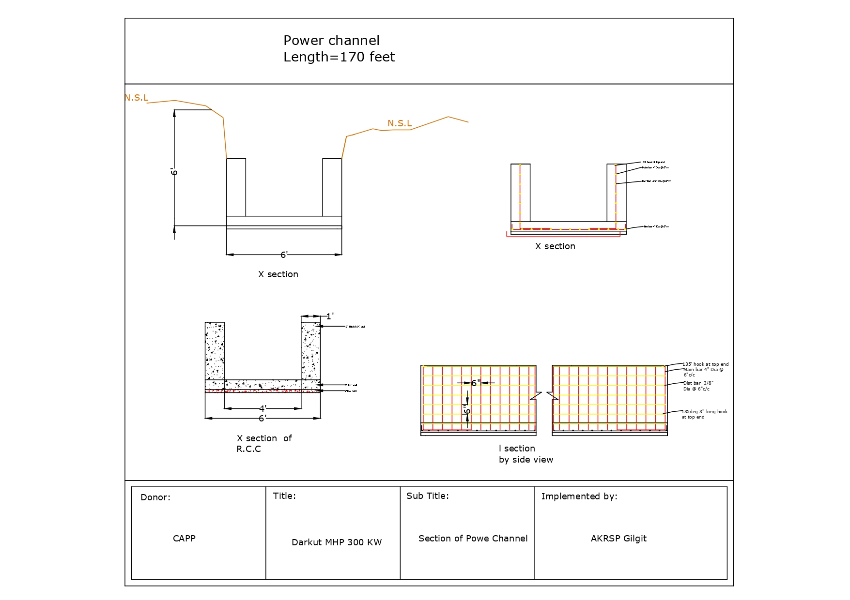

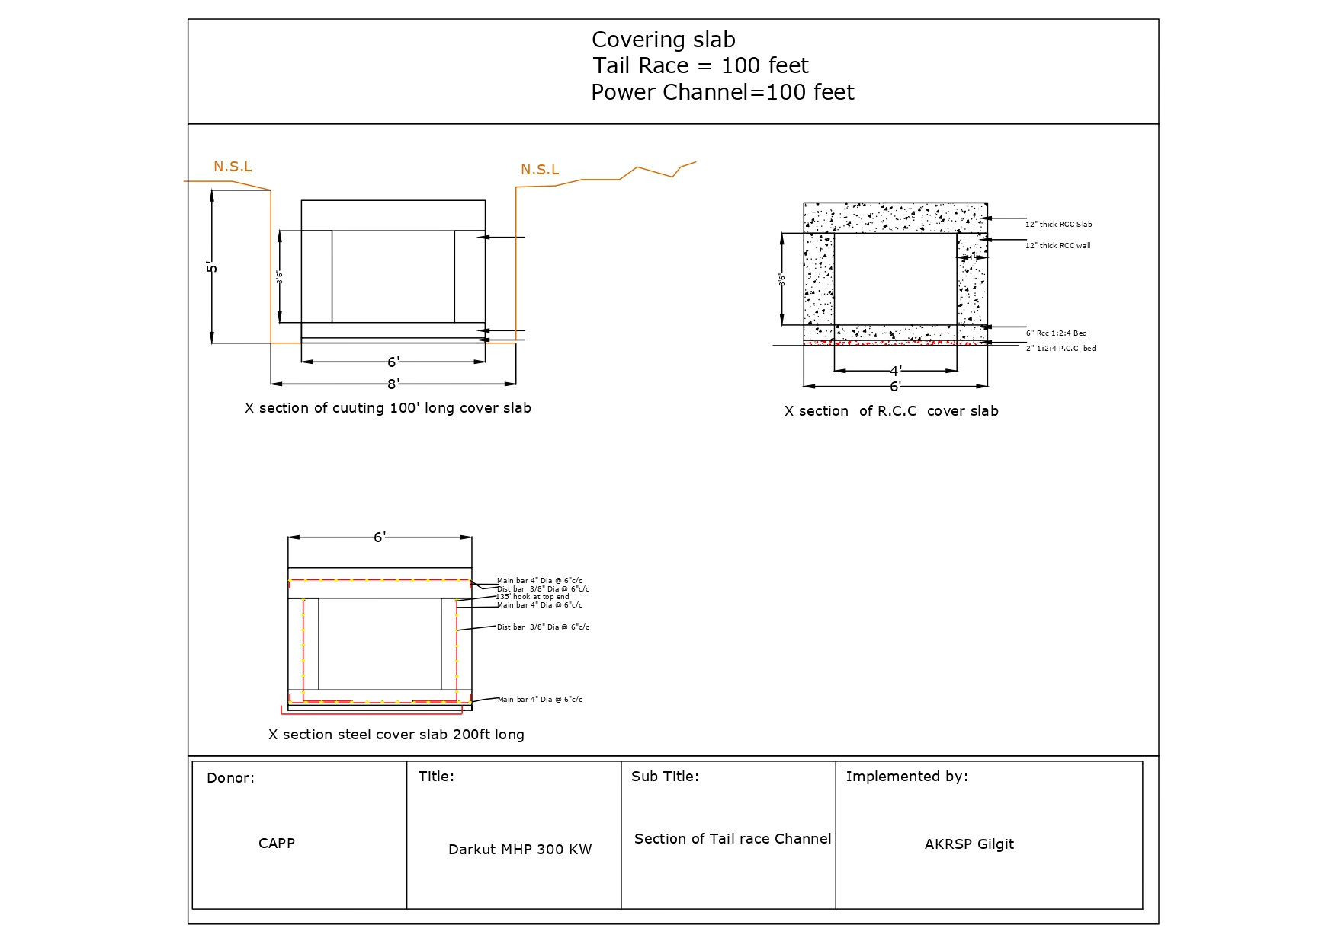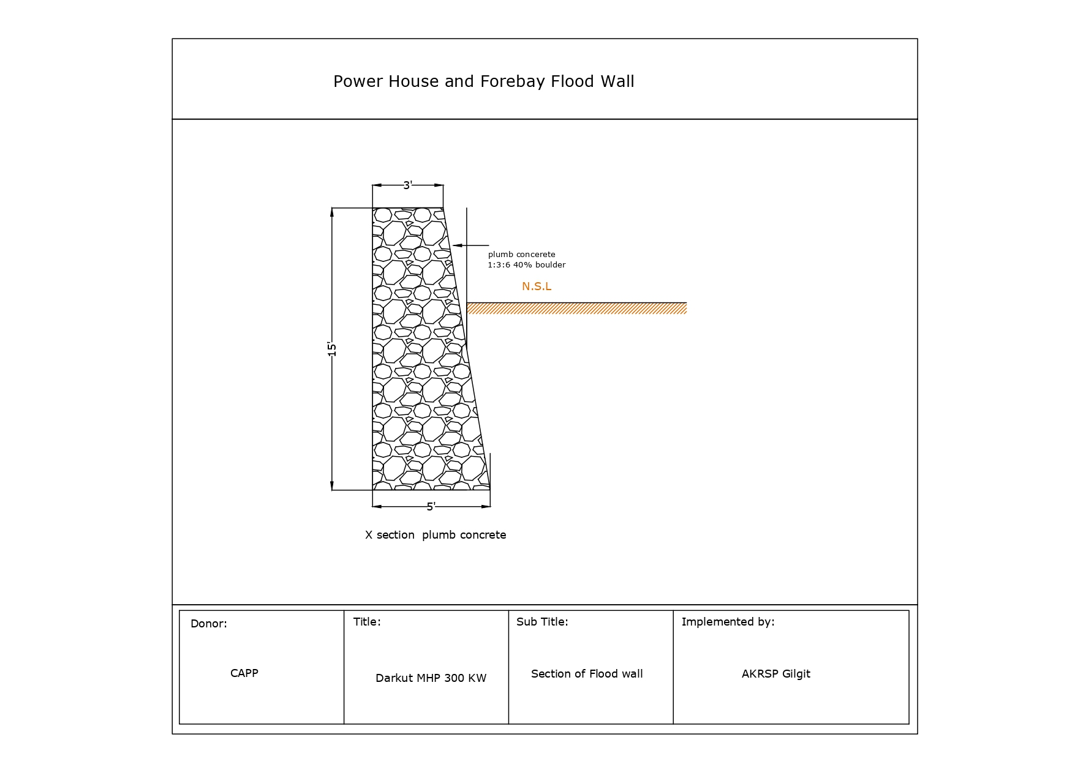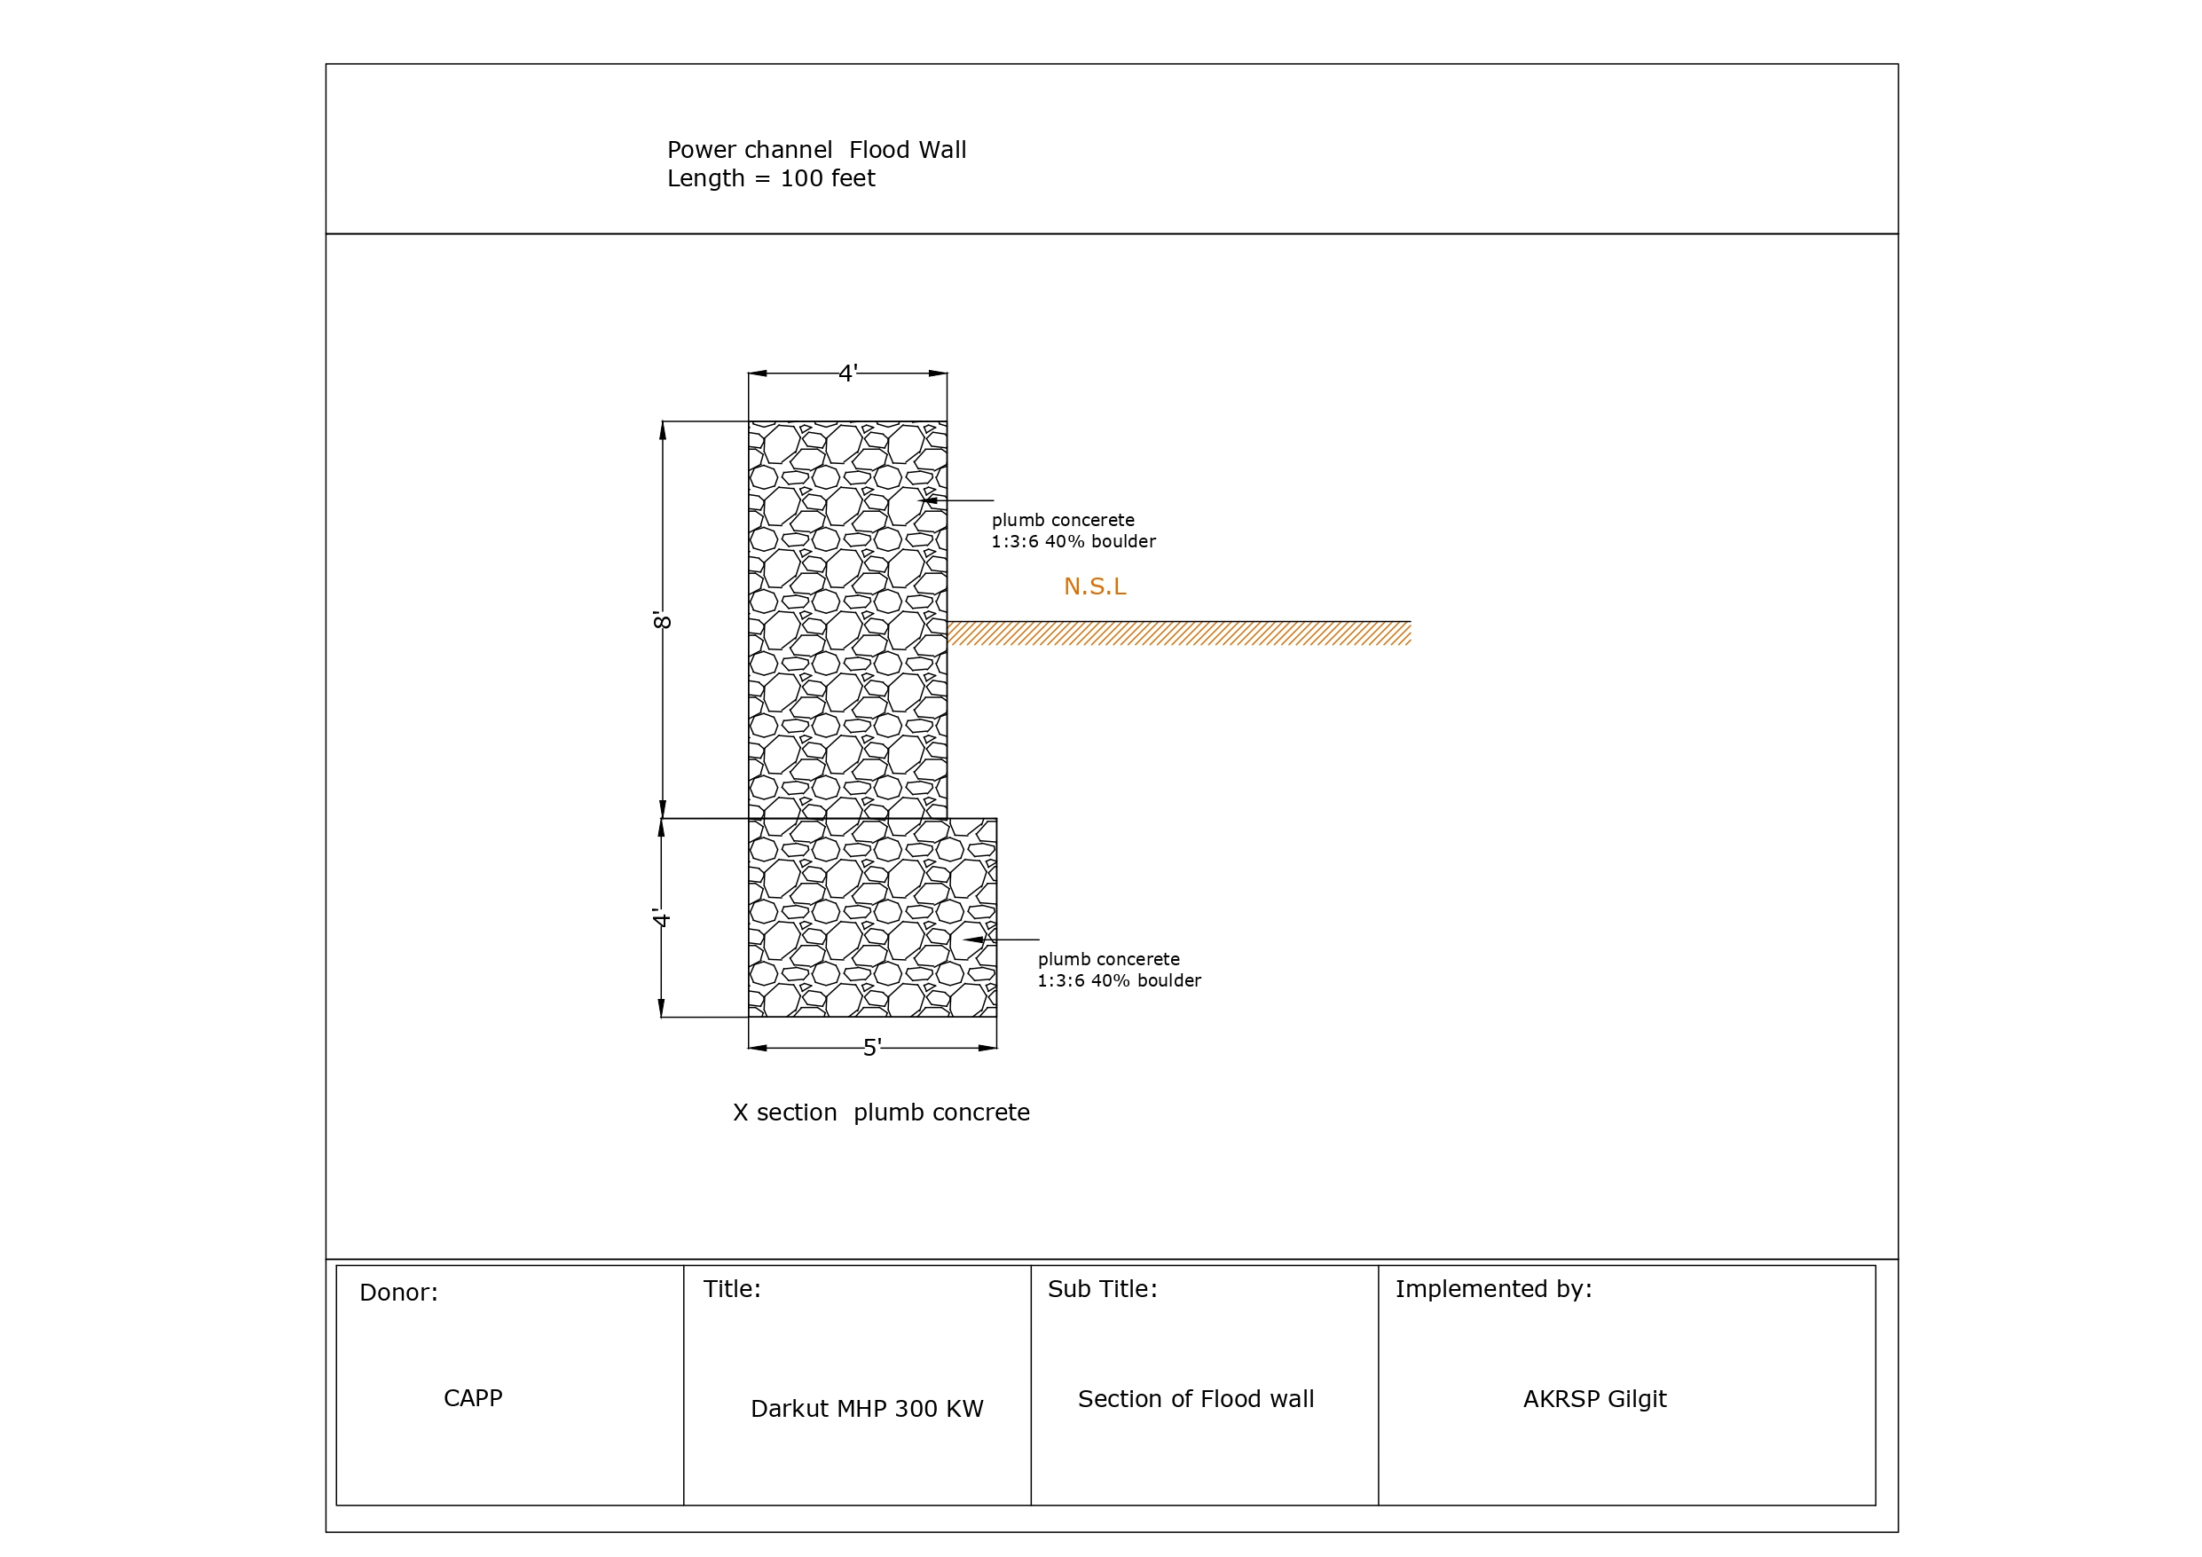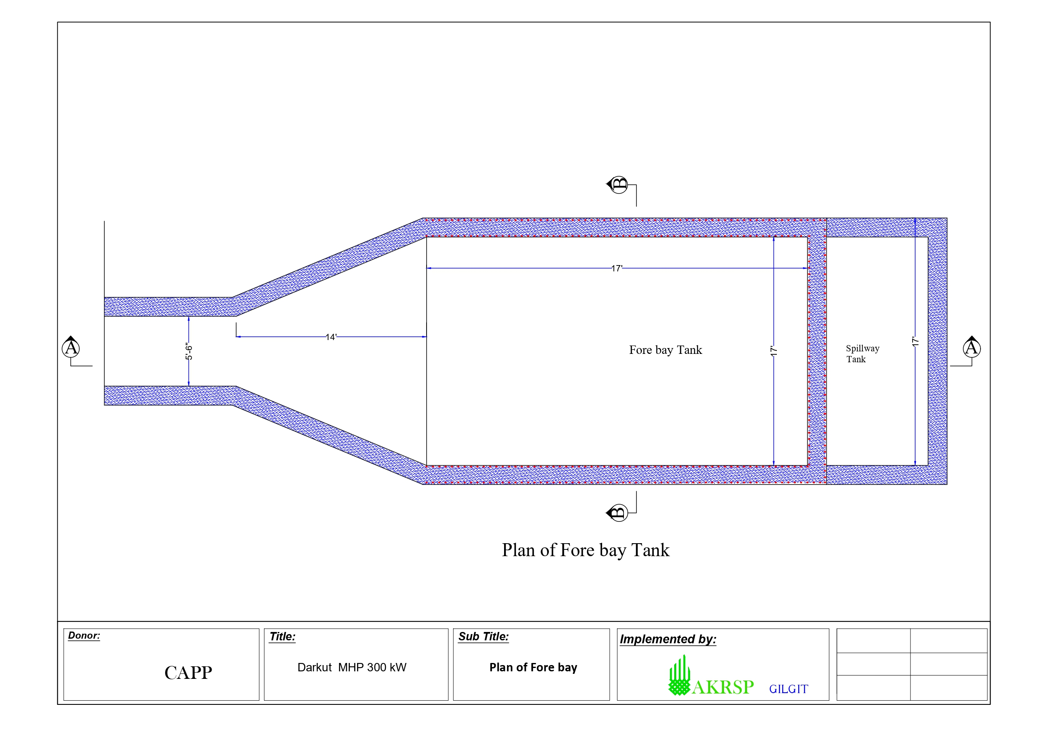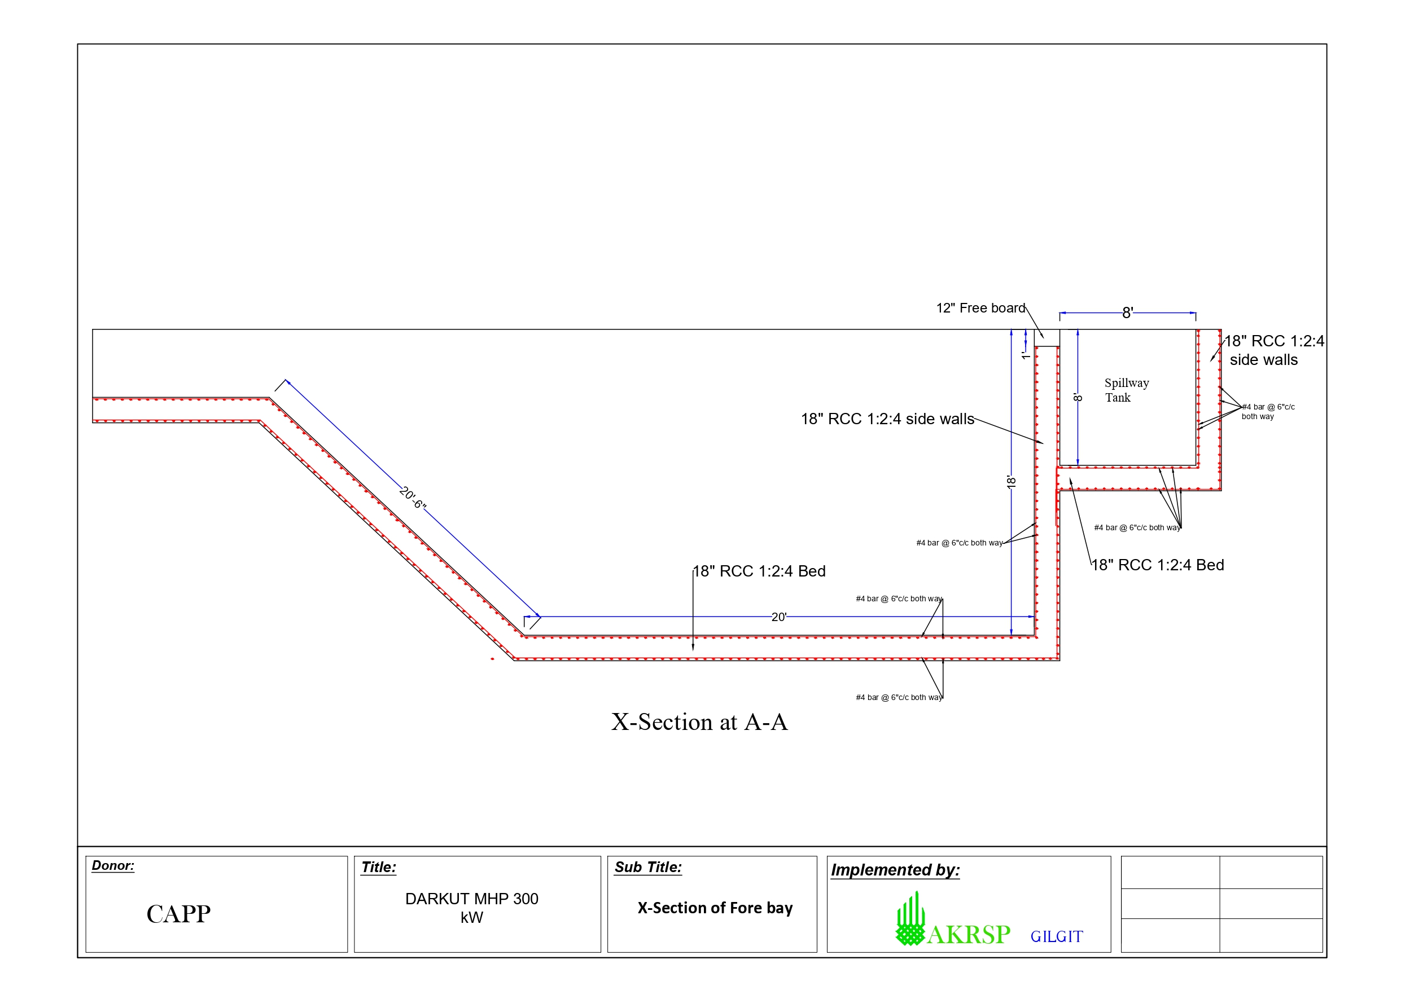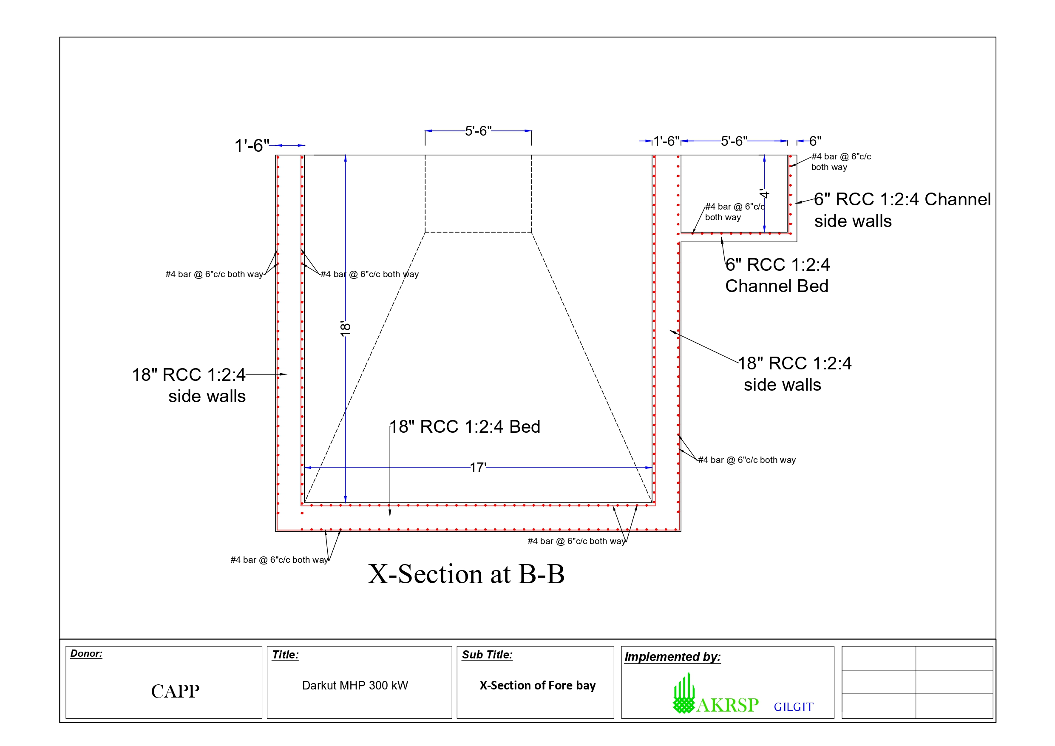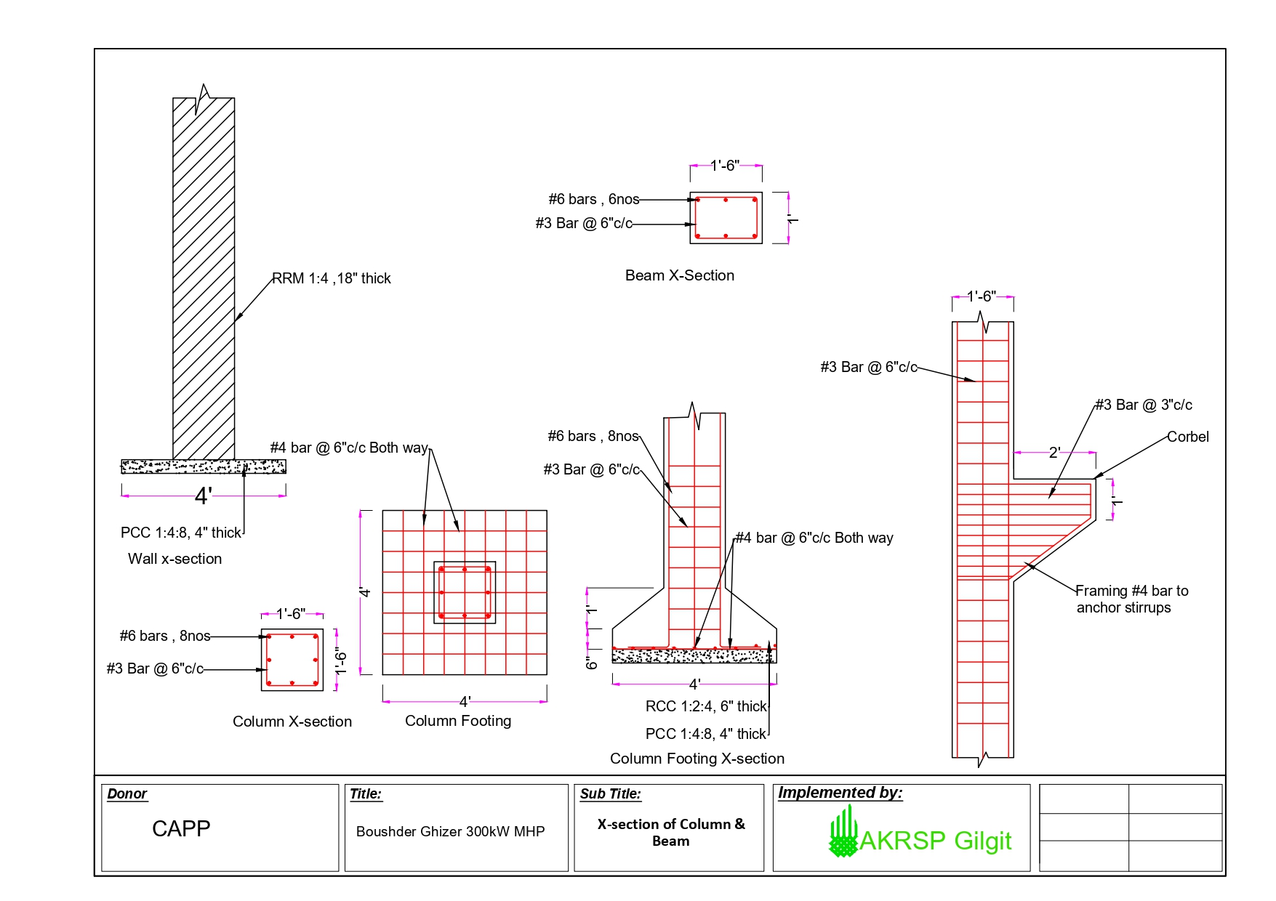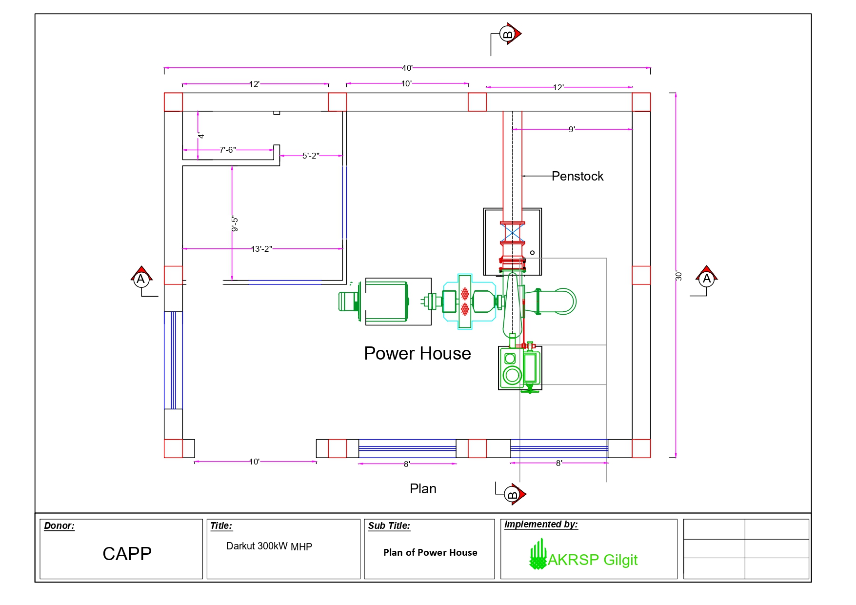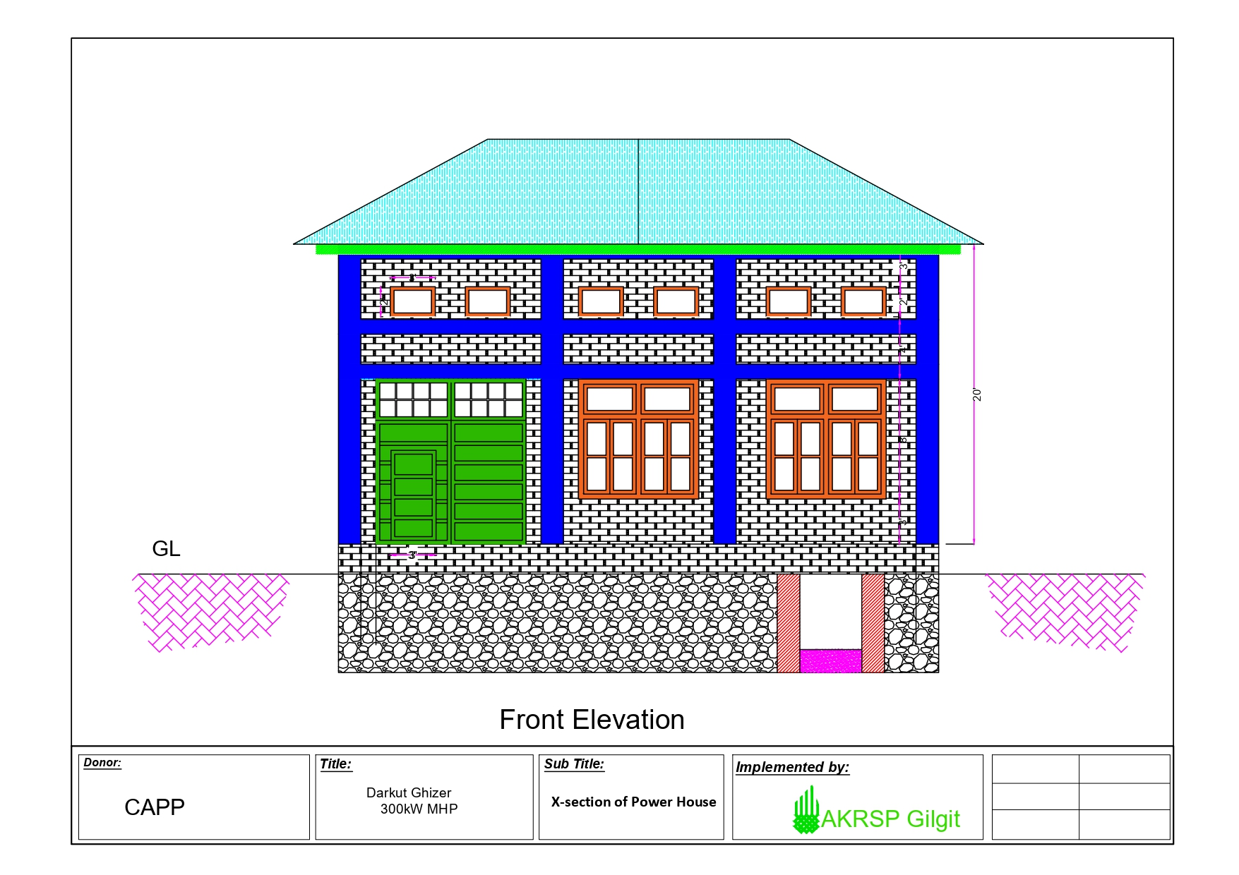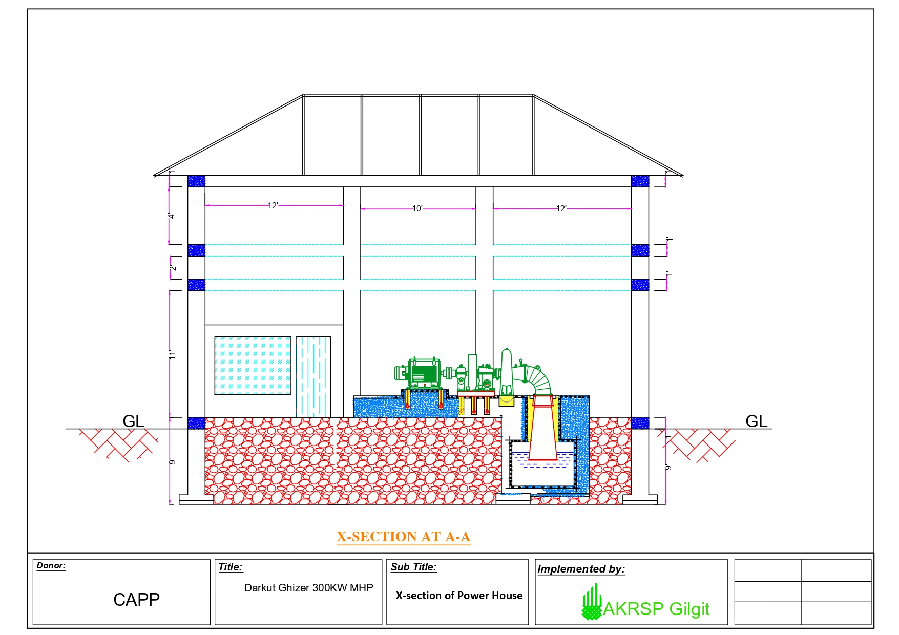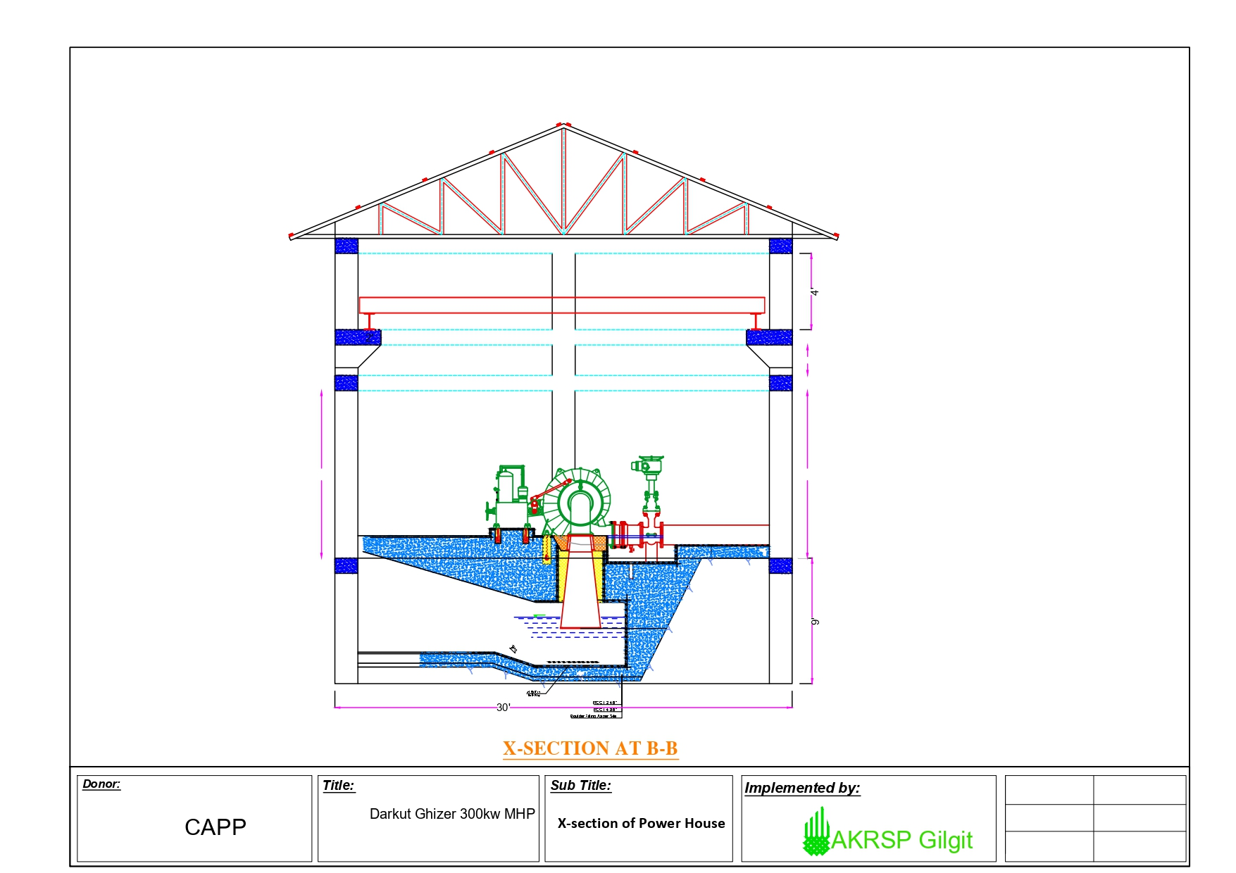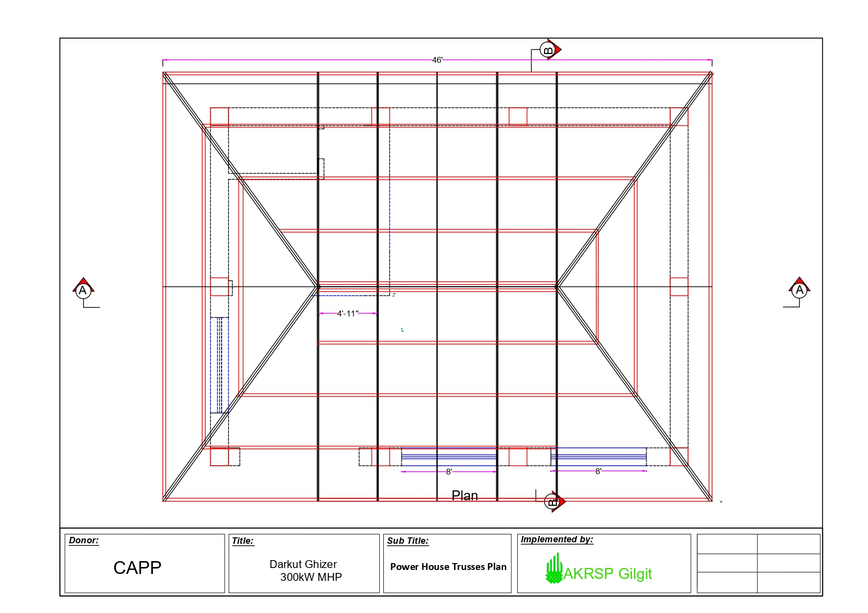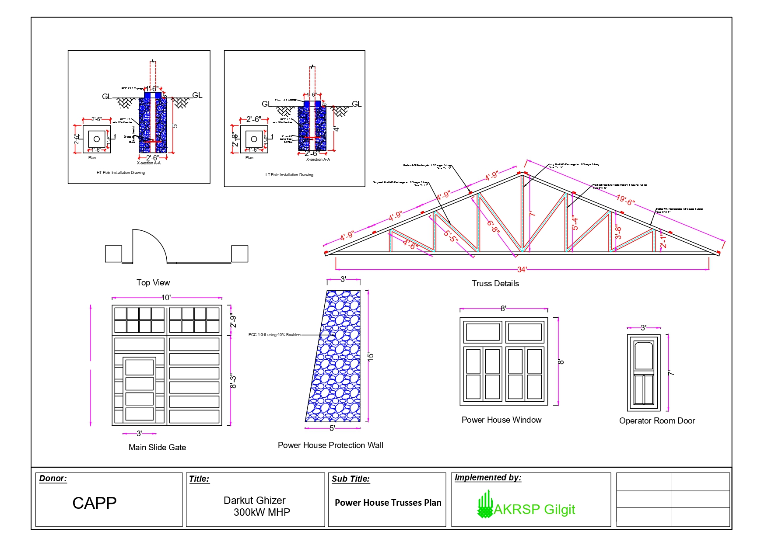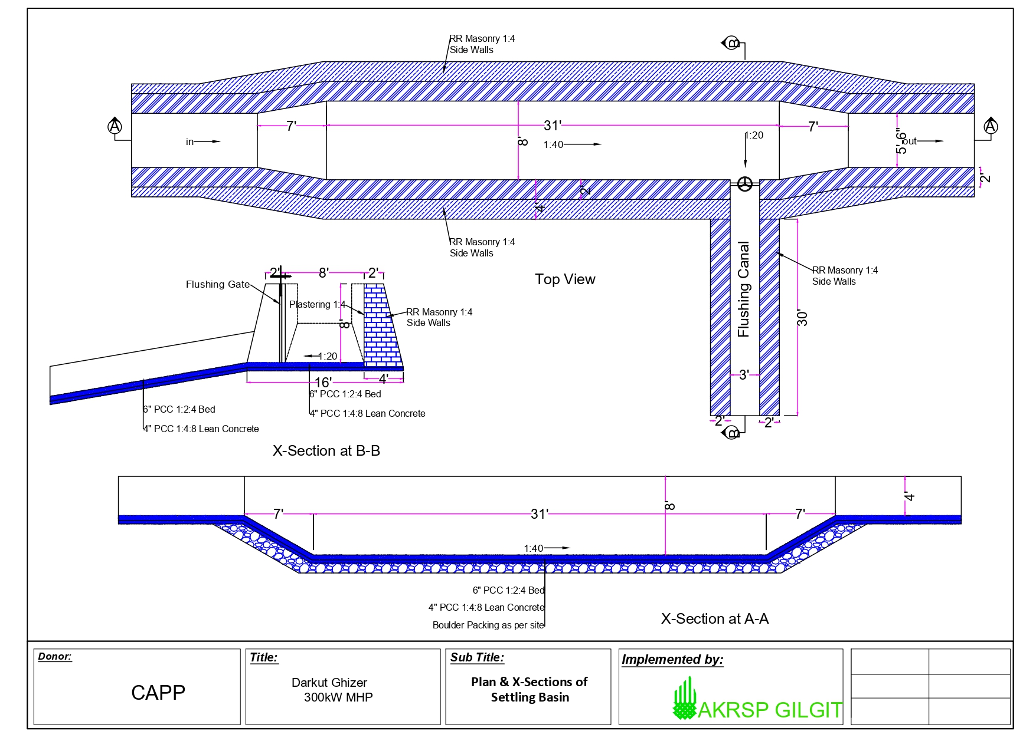

Construction of 300 kW Darkut MHP in Ghizer

Section 5: Contract Form and Conditions of Contract

Content
1. Letter of Acceptance 2
2. Contract Form 3
3. Appendix to Contract 4
4. Advance Payment Security 14

1. Letter of Acceptance

Yasmeen Qalander
Regional Programme Manager
Aga Khan Rural Support Programme,
Regional Programme Office Noor Colony near Bus Stand Gilgit
Letter of Acceptance

Subject: Notification of Award for Contract No........................
This is to notify you that your Bid dated ................ for execution of the
Construction of 300 kW Darkut MHP in Ghizer
for the Accepted Contract Amount of
PKRs_________________________________
(in words_______________________________________________)
as corrected and modified in accordance with the Instructions to Bidders, is hereby accepted. You are requested to furnish the Performance Security for the Regular Items in the amount of
PKRs________________________________
within 14 days in accordance with the Conditions of Contract, by using the Performance Security Form included in Section 8 (Contract Forms) of the Bidding Document.

Authorized Signature: ..........................................................................
Title and Name of Signatory.................................................................
Name of Agency...................................................................................

Attachment: Contract Agreement

2. Contract Form

Reference No. / Short Tag _______________________

Between the Aga Khan Rural Support Programme (AKRSP)

and
hereinafter referred to as the ‘Contractor’

the following agreement _______________________

for execution of Construction of 300 kW Darkut MHP in Ghizer

, hereinafter referred to as the ‘Works’.
is made:

Type of Contract:

(a) measured contract,
(b) milestone lump sum,
(c) mixed contract of (a) and (b)
(tick one only!)
The Contractor has offered to execute the Works as general contractor as per the terms and conditions listed in the Appendix, which forms part of this Agreement, and offers to execute the Works in conformity with the Contract for the sum of (contract sum without contingencies)
PKRs__________________ (in figures)
PKRs (in words)

This Offer, in this form of an Agreement, will become the Agreement if
a) accepted by the AKRSP and signed by all parties
or
b) corrected for arithmetical errors and then signed by all parties.

All documents listed in the Appendix and the Appendix will form part of the Agreement.

Signature: Date:

Name: Authorized to sign on behalf of

(Construction Company)
Capacity: (stamp)

3. Appendix to Contract
1. Documents forming the Contract listed in the order of priority
A) the Agreement
B) this Appendix
C) the Annexes
Annex 1: Minutes of Clarification Meeting
Annex 2: Technical Specifications
Annex 3: Drawings, Standard Designs, Conceptual Plan, Sketches, etc.
Annex 4: Basis of Payment: for type (a) Bill of Quantities (priced) *), for type (b) Payment Schedule
Annex 5: Technical Description of Work, Studies and other Reports
Annex 6: Global time Schedule and/or Sequence of Works (Implementation Plan)
Annex 7: Contractor´s Detailed Implementation Schedule / Works Programme
Annex 8: Declaration of Undertaking *)
Annex 9: Valid Registration *)
Annex 10: CVs of Contractor´s Key Staff for the project *)
Annex 11: List of Contractor’s Equipment for the project *)
Annex 12: Form of Performance Bond **)
Annex 13: Minimum Labour Standards (construction)
Annex 14: Workers Health & Safety Plan including incident reporting (construction)
*) Annexes 8 to 11 and priced Bill of Quantities as submitted with the tender by the bidder or as agreed upon.
**) The Contractor shall deliver to the AKRSP within 14 days of the Commencement Date a Performance Security as stated in section 1.
The documents forming the Contract are to be taken as mutually explanatory of each other. The priority of the documents shall be in accordance with the order as listed above. Documents with a higher priority overrule documents with a lower priority. If an ambiguity or discrepancy is found in the documents that is not clarified by the overruling regulation the AKRSP shall issue any necessary instructions to the Contractor.

2. Time for Completion
calendar days, i.e. starting date of works , completion date.

3. Law of the Contract
Law of Pakistan, as far as applicable.

4. Language of the Contract
The Contract language is the English language.

5. Commencement of Works
Works are to be commenced within calendar days from signing of contract.
6. Contractor’s responsible supervising Engineer who manages the Project
Name: Phone:

7. Contractor’s other key staff: (list all required positions)
a) Position:

Name: Phone:

b) Position:

Name: Phone:

c) Position:

Name: Phone:

d) Position:

Name: Phone:

8. Contractor’s Equipment
Contractor´s key equipment as per Annex 11 has to be on site and operable at all times as required per project phase. Standard tools and any other equipment have to be on site in sufficient numbers and be operable at all times as per project requirements.

9. Contractor’s Account Information
Account Holder
Account No.
Bank
IBAN _____________________________
SWIFT
Corresponding Bank

10. AKRSP’s representatives
a) Client´s Engineer:

(company)

represented by:

(name)

, Technical Unit Leader;

11. AKRSP’s Liability
- The AKRSP shall provide the Site and right of access thereto as required.
- The AKRSP is liable for the Design, respectively the basis of Contractor´s Design as provided in Annex 3.

12. AKRSP’s Instructions
The Contractor shall comply with all instructions given by the AKRSP in respect of the Works including the suspension of all or part of the Works.

13. Approvals
No approval or consent or absence of comment by the AKRSP or the AKRSP's representative shall affect the Contractor's obligations.

14. General Obligations of the Contractor
The Contractor shall carry out the Works properly and in accordance with the Contract. The Contractor shall check the BoQs and designs prior to execution and shall give notice in due time if he discovers mistakes.
In case the Contractor carries out design works as specified in Annex 2, Specifications as per Annex 4, or BoQs, he shall be responsible for the design including mistakes not discovered during approval. He shall also be responsible for mistakes not discovered in the BoQs, even he was not tasked to prepare these.
The Contractor shall deliver the design promptly and latest as per the agreed upon work Programme (Annex 7). Corrections as per the AKRSP´s instruction shall be made promptly and works shall not start before the AKRSP´s approval of the Design.
The Contractor shall provide all supervision, labour, Materials, Plant and Contractor's Equipment which may be required. All Materials and Plant on Site shall be deemed to be the property of the AKRSP.

15. Compliance with Laws and Regulations
It is the responsibility of the contractor to comply with all laws and regulations in Pakistan, including social, environmental and hygiene standards and liabilities to third parties. The Contractor shall give all notices and pay all fees and other charges in respect of the Works.
Only non-hazardous and environmental friendly materials shall be used, e.g. no asbestos and no paint etc. that have negative impact on health.
The Contractor shall draw up a Health and Safety Plan for approval through the AKRSP which has to be adhered to.

16. Contractor’s Representative
The Contractor shall submit to the AKRSP for consent the name and particulars of the person authorised to receive instructions on behalf of the Contractor.

17. Subcontracting
The Contractor is not permitted to subcontract the whole of the Works. The Contractor shall not subcontract any part of the Works without the written consent of the AKRSP.

18. Execution of the Works
The Contractor shall commence the Works on the Commencement Date and shall proceed expeditiously and without delay and shall complete the Works within the Time for Completion.

19. Programme
A detailed Works-Programme/Time Schedule, based on the Time Schedule already submitted with the tender documents and attached to this Agreement will be submitted by the Contractor within two weeks after signing of the contract and is a precondition for any first payment. This detailed Programme will become part of the contract (Annex 6) after approval through the AKRSP. Dates for the completion of milestones/major components will be fixed in this Works Programme.

20. Extension of Time
The Contractor shall be entitled to an extension of the Time for Completion if he is or will be delayed by any of the AKRSP's Liabilities or through Force Majeure.
The Contractor has to apply for Extension of Time within one week of the occurrence of the cause of the delay.
On receipt of an application from the Contractor, the AKRSP will consider all supporting details provided by the Contractor in due time and will extend the Time for Completion as appropriate.

21. Late Completion
Failure to complete the Works or to achieve the agreed progress due to default of the contractor may result in termination of this agreement in conformity with the Termination and Repayment Clause. Deduction of 0.1% (zero point one percent) of Contract Sum per calendar day up to a total deduction of 10 % can be applied. As soon as such delays become evident, the deduction may be applied on interim payments.

22. Completion and Inspection thereof
The Contractor may notify the AKRSP when he considers that the Works are complete. When this notice is given, all works must have been executed. The AKRSP shall then inspect the works for Handing over.

23. Technical Standards
The Contractor will adhere to the prevailing technical standards in Pakistan and the attached Specification as applicable and apply all diligence and care customary in his field of operation and as far as possible under the given circumstances.

24. Remedying Defects
The Contractor will execute the Works to the best professional practice according to abovementioned Technical Standards. Payments will only be released for correctly executed works. Substandard work has to be redone or will be executed at the expense of the contractor even at higher cost. The contractor will be liable for defects becoming apparent during defects liability period of 12 months. The payment of the retention money will only be made after correction of such defects and after the end of DLP. The AKRSP reserves the right to reduce the payment in case such corrections are unsuccessful or unreasonably delayed, or to get defects corrected at the expense of the contractor.
The AKRSP also may at any time prior to the expiry of the liability period notify the Contractor of any defects or outstanding work. The Contractor shall remedy at no cost to the AKRSP any defects due to the Contractor's design, Materials, Plant or workmanship not being in accordance with the Contract.

25. Uncovering and Testing
The AKRSP may give instruction as to the uncovering and/or testing of any work. Unless as a result of any uncovering and/or testing it is established that the Contractor's design, Materials, Plant or workmanship are not in accordance with the Contract, the Contractor shall be paid for such uncovering and/or testing as a Variation.

26. Variations
All additional/variated works, if any, have to be agreed upon in writing with the AKRSP before executing. A standard form for this request will be handed over to the contractor. Additional/variated works executed without written agreement will not be paid. The value of variations will be determined on the basis of the BoQ rates as far as applicable.

27. Early Warning
A Party shall notify the other as soon as he is aware of any circumstance which may delay or disrupt the Works, or which may give rise to a claim for additional payment. The Contractor shall take all reasonable steps to minimize these effects.
The Contractor's entitlement to extension of the Time for Completion or additional payment shall be limited to the time and payment which would have been due if he had given prompt notice and had taken all reasonable steps.

28. Right to Claim
If Cost incurs for the Contractor as a result of any of the AKRSP's Liabilities, the Contractor shall be entitled to the justified and reasonable amount of such Cost. If as a result of any of the AKRSP's Liabilities it is necessary to change the Works, this shall be dealt with as a Variation.

29. Claim Procedure
The Contractor shall submit to the AKRSP an itemised make-up of the value of Variations and claims within 28 days of the Instruction of the AKRSP or of the event giving rise to the claim. The AKRSP shall check and if possible agree the value. In the absence of agreement, the AKRSP shall determine the value.

30. Valuation of the Works
The Works shall be valued according to remeasurements with Bill of Quantities for measured contracts and as per each milestone in the payment schedule fully completed for lump sum-milestone contracts.
Costs for construction equipment and other materials required to carry out the works are to be included in the tender prices and cannot be claimed separately.

31. Payments and Performance Bond:
31.1 For measured contracts (type (a)):
The Contractor shall be entitled to be paid at monthly intervals:
a) the value of the Works executed,
b) 80% of the value of Materials delivered to the Site at a reasonable time, but not exceeding 30% of the amount for finished works.
This is only applicable if the Contractor has given the material component cost for these items in his tender, and after this has been accepted as reasonable before contracting.
c) subject to any additions or deductions which may be due.
31.2 For milestone-lump sum contracts (type (b)):
Payment shall be on milestones completed as per payment schedule.
31.3 For mixed contracts (type (c)):
One defined component is based on Bill of Quantities as for type (a) contracts above; the other is based on milestones as for type (b).
31.4 All contract types are not subject to a price adjustment, i.e. the rates respectively, the milestone payments and contract unit rates are fixed and are not subject to inflation, rise in market prices, variation of quantities (for milestone contracts) or similar.
31.5 The Contractor shall deliver to the AKRSP within 14 days of the Commencement Date a Performance Security in the form handed out with the Tender documents and from a third party approved by the AKRSP over 10 % of the Contract Sum as per Section "A.2: Acceptance" of this Contract valid until the closing date of this contract. The delivery of the Performance Bond is a precondition for any payment within this contract. The Performance Bond will be kept at the AKRSP’s Head office and will be discharged/returned by the AKRSP after handing over of the Works under the Contract and their acceptance through the AKRSP.

32. Interim Payments
Within 28 days of delivery of each statement, i.e. date of confirmed receipt, the AKRSP shall either state refusal of payment with reasons given in writing or pay to the Contractor the amount shown in the Contractor's statement less retention for defects liability at the rate of 8% (eight percent) unless for lump sum-milestone payments calculated considering the retention for defects liability, and less any amount for which the AKRSP has specified his reasons for disagreement. The AKRSP shall not be bound by any sum previously considered by him to be due to the Contractor.

33. Form of Payments
Payments are made by the AKRSP and will be disbursed after checking (checking of measurement for type a and c contracts) of the Works through the Engineer. Payments will be made on the Contractor's bank account stated in paragraph 9.

34. Currency of Payments
Payments will be made in PKRs

35. Payment of Retention
The retention shall be paid by the AKRSP to the Contractor within 28 days after either the expiry of the defect liability period or the remedying of notified defects; whichever is the later, and presentation of the respective contractor’s invoice.

36. Final Invoice
Final invoices for the executed works will be presented by the Contractor within 28 days after completion.

37. Insolvency
If the Contractor is declared insolvent under any applicable law, the AKRSP may by notice terminate the Contract immediately. The Contractor shall then demobilise from the Site, leaving behind any Contractor's Equipment, installations and materials which the AKRSP instructs in the notice is to be used until the completion of the Works.

38. Termination Clause
a) Default of the Contractor:
The AKRSP may terminate this Agreement if the Contractor still fails to perform the agreed services, is seriously delaying the works Programme and time schedule or is otherwise in serious breach of the Contract after two subsequent notifications by the AKRSP as to his failure (term of notice for the first one 21 days, for the second one
14 days). In this case the Contractor has to compensate the AKRSP for all cost resulting from this termination.
b) Termination by the AKRSP:
The AKRSP may at any time terminate the contract due to reasons not related to the contractor, or due to Force Majeure.
The Contractor shall in this case be compensated for all works executed so far, including partially completed works, as defined under the clause for Force Majeure.
The net balance due shall be paid or repaid within 28 days of the notice of termination.

39. Repayment Clause
The AKRSP may request re-payment of any amounts disbursed if the Contractor fails to perform the services as described in this Agreement. Repayments will be made immediately by the Contractor in a form determined by the AKRSP and confirmed in writing by the AKRSP, directly to the account of the AKRSP.
(IBAN and S.W.I.F.T. __________________); Account ________________ NUMBER, through a recognized international Bank in Pakistan.

40. Contractor’s Care of the Works
The Contractor shall take full responsibility for the Care of the Works from the Commencement Date until the date of the Completion certificate. If any loss or damage happens to the Works during the above period, the Contractor shall rectify such loss or damage at his own cost so that the Works conform to the Contract.

41. Force Majeure
"Force Majeure" means an exceptional event or circumstance; which is beyond a Party's control; which such Party could not reasonably have provided against before entering into the Contract; which, having arisen, such Party could not reasonably have avoided or overcome; and, which is not substantially attributable to the other Party, such as:
a) war, invasion,
b) rebellion, terrorism, revolution, insurrection, military or usurped power, or civil war, within the Project Area
c) riot, commotion or disorder by persons other than the Contractor's personnel and other employees, affecting the Site and/or the Works,
d) any operation of the forces of nature affecting the Site and/or the Works, which was unforeseeable or against which an experienced contractor could not reasonably have been expected to take precautions.
If a Party is or will be prevented from performing any of its obligations by Force Majeure, the Party affected shall notify the other Party immediately. If necessary, the Contractor shall suspend the execution of the Works and, to the extent agreed with the AKRSP, demobilize the Contractor's Equipment.
If the event continues for a period of 84 days, either Party may then give notice of termination, which shall take effect 28 days after the giving of the notice.
After termination, the Contractor shall be entitled to payment of the unpaid balance of the value of the Works executed and of the Materials reasonably delivered to the Site, adjusted by the following:
a) any sums to which the Contractor is entitled under title: “Materials”
b) the Cost of his suspension and demobilization,
c) any sums to which the AKRSP is entitled.
The net balance due shall be paid or repaid within 28 days of the notice of termination.

42. Contractor's liability:
The contractor is fully liable for the safety on site and all losses or damages, especially:
a) for loss and damage to the Works, Materials, Plant and the Contractor's Equipment,
b) for loss, damage, death or injury to third parties or their property arising out of the contractor's performance of the Contract
c) for death or injury to the Contractor's personnel
In case of design-build contracts, the contractor is also responsible for his design.

43. Extent of Insurance Cover
The Contractor shall, prior to commencing the Works, effect and thereafter maintain insurances for the following liabilities to an extent of the Accepted Contract Sum multiplied by 1.2:
a) for loss and damage to the Works, Materials, Plant and the Contractor's Equipment,
b) for liability for loss, damage, death or injury to third parties or their property arising out of the Contractor's performance of the Contract, including the Contractor's liability for damage to the AKRSP's property other than the Works,
c) for liability for death or injury to the Contractor’s personnel.

44. Failure to Insure
If the Contractor fails to effect or keep in force any of the insurances referred to in the previous Clauses, he has to indemnify the AKRSP or third parties for all subsequent losses.
The contractor is fully liable for the safety on site and all losses or damages.

45. Arbitration
All disputes arising from, or in connection with, this Contract should be settled amicably between the contracting parties.
All disputes that cannot be settled amicably by the connecting parties shall be settled by a Dispute Adjudication Board consisting of three arbitrators, aligned with the FIDIC Conditions of Contract for Plant and Design-Build, Sub-Clauses 20.2 to 20.4.
If the decision of the Dispute Adjudication Board is refused by at least one of the parties the dispute shall be finally and exclusively settled in accordance with the Rules of Conciliation and Arbitration of the International Chamber of Commerce in Paris.
Cost for Dispute Adjudication and Arbitration shall be borne by the Contractor whereas the AKRSP shall reimburse 50% of the cost.

46. Salvatory Clause
The invalidity of any provision of this Contract shall not affect the validity of the remaining provisions. Any gap resulting in consequence shall be filled by a provision consistent with the purpose of this Contract.

47. Waiver
Failure of either party to insist upon strict performance by the other party of any provision of the Contract shall in no way be deemed or construed to affect in any way the right of that party to require such performance.

48. Other Provisions
a) The AKRSP will have the right to inspect the works and assess the progress at any time. and ask for the invoices of purchasing the items, source of purchasing and pictorial evidence of the activities for quality purpose.
b) All works must be inspected and approved before they are covered.
c) The Contractor will provide adequate proof of works progress at least once a month with measurement sheets and sketches that allow easy checking, for measured works and for lump-sum contracts about milestones completed and those under execution. The measurement sheet must be signed by the Contractor’s site engineer and endorsed by AKRSP’s site Engineer.
d) The Contractor will furnish and erect a construction signboard, with text provided by the AKRSP at a location directed by the AKRSP.
e) The AKRSP will issue a completion certificate latest within 4 weeks of handing over of the whole of the works provided all items in punch lists have been rectified.
f) Provisional/optional items shall only be executed if ordered specifically. The price for provisional items as offered remains valid for 24 months.
g) Invoices have to be checked and verified first by the responsible engineer of the Contractor who will forward them to the AKRSP for checking and approval.
h) A qualified resident engineer of the contractor has to be on site at all times. The resident engineer may only be replaced with the prior approval of the AKRSP through an engineer with at least equal qualification. The AKRSP reserves the right to request the replacement of the engineer at any time if his performance does not match the required standards.
i) The contractor is obliged to have a valid license at all times.
j) Any contractual communication and modification or update of information must be in writing.
k) The project will follow standardized procedures for checking, approval etc. An overview over these procedures will be handed out to the Contractor.
l) The Contractor shall hold regular meetings (on a weekly basis, or as otherwise instructed by the AKRSP) with the AKRSP to discuss progress and issues related to Project implementation.
m)By signing the contract, the Contractor agrees to implement the works according to the requirements of the AKRSP Environmental and Social Policy.

4. Advance Payment Security

Bank Guarantee (to be issued on letterhead of bank)
Address of guarantor bank:
.............................................................................
.............................................................................
.............................................................................

Aga Khan Rural Support Programme (AKRSP)
On ...................................... you concluded with ................................................. ("Contractor") a contract for ................................................................. (project, object of contract) at a price of ................................................................EUR.

In accordance with the provisions of the contract the Contractor receives an advance payment in the amount of .........................., which represents .................. % of the order value.

We, the undersigned ............................. (Guarantor), waiving all objections and defenses under the aforementioned contract, hereby irrevocably and independently guarantee to pay on your first written demand any amount advanced to the Contractor up to a total of ............................................................... (in words: ..................................................................) against your written declaration that the Contractor has failed to duly perform the aforementioned contract.

This guarantee shall come into force and effect as soon as the advance payment has been credited to the account of the Contractor.

In the event of any claim under this guarantee, payment shall be effected AKRSP BIC: _______________, account IBAN: __________________.

This guarantee shall expire no later than *...........................................

By this date we must have received any claims for payment by letter or encoded telecommunication.

It is understood that you will return this guarantee to us on expiry or after payment of the total amount to be claimed hereunder.

This guarantee is governed by the laws of ............................

…………………………… ……………………………
Place, date Guarantor

Note:* Insert the date twenty-eight days after the expected date of repayment of Advance Payment Security.

5. Performance Security
Bank Guarantee (to be issued on letterhead of bank)
Address of guarantor bank:
.............................................................................
.............................................................................
.............................................................................

Aga Khan Rural Support Programme (AKRSP)
Babar road Kashrote Gilgit

On ..........................you concluded with ................................................. ("Contractor") a contract for ................................................................. (project, object of contract) at a price of ................................................................. PKR.

In accordance with the provisions of the contract the Contractor is obligated to provide a performance bond for ........... % of the contract price.

We, the undersigned ...................... (“Guarantor”), waiving all objections and defenses under the aforementioned contract, hereby irrevocably and independently guarantee to pay on your first written demand an amount up to a total of ....................................... (in words: ................................................................................) against your written declaration that the Contractor has failed to duly perform the aforementioned contract.

In the event of any claim under this guarantee, payment shall be effected to Aga Khan Rural support Programme BIC: _______________, account IBAN: _______________________.

This guarantee shall expire no later than ...........................................

By this date we must have received any claims for payment by letter or encoded telecommunication.

It is understood that you will return this guarantee to us on expiry or after payment of the total amount to be claimed hereunder.

This guarantee is governed by the laws of ..........................................

................................................... ...................................................
Place, date Guarantor

Capitalised terms used, but not otherwise defined in this Declaration of Undertaking have the meaning given to such term in AKRSP’s “Guidelines for the Procurement of Consulting Services, Works, Plant, Goods and Non-Consulting Services in Financial Cooperation with Partner Countries”.
In case ILO conventions have not been fully ratified or implemented in the Employer’s country the Applicant/Bidder/Contractor shall, to the satisfaction of AKRSP, propose and implement appropriate measures in the spirit of the said ILO conventions with respect to a) workers grievances on working conditions and terms of employment, b) child labour, c) forced labour, d) worker’s organisations and e) non-discrimination.
In the case of a JV, insert the name of the JV. The person who will sign the application, bid or proposal on behalf of the Applicant/Bidder shall attach a power of attorney from the Applicant/Bidder.

