
Aga Khan Rural Support Program (AKRSP)
REQUEST FOR QUOTATION (RFQ)

RFQ No:AKRSP/419/2025 Delivery Point: Different Location Upper & Lower Chitral

RFQ Date: October 07, 2025 Submission Date: October 21, 2025

Subject: Request for Quotation for Supply, Transportation & Installation of Aluminum Glasses, CGI Sheets, and Thermophore Sheets for Passive Solar Greenhouse Projects
The Aga Khan Rural Support Programme (AKRSP) invites sealed quotations from qualified, reputable, and experienced vendors for the Supply, Transportation, and Installation of Aluminum Glasses, CGI Sheets, and Thermophore Sheets for Passive Solar Greenhouse Projects at multiple locations across Upper and Lower Chitral.
This RFQ provides the complete scope of work, specifications, evaluation criteria, and contractual terms and conditions. Vendors are advised to review this document thoroughly and prepare their quotations accordingly. Clarifications, if any, must be requested well before the submission deadline.
1. Scope of Work
The primary objective of this procurement is to ensure the timely supply, transportation, and installation of high-quality materials for the construction of Passive Solar Greenhouses in different valleys of Chitral under AKRSP’s ongoing climate resilience and livelihood enhancement initiatives.
All works must be executed in accordance with AKRSP’s specifications and under the supervision of the technical team.
2. Locations and Physical Targets
Greenhouses (40’x15’ size):
Location | Physical Target | Distance from Chitral (km)
Tar (Shishikoh) | 1 | 55
Syed Abad (Gahirate) | 1 | 25
Undetermined (Between Chitral town & Broze) | 1 | 18
Total | 3

Greenhouses (30’x15’ size):
Location | Physical Target | Distance from Chitral (km)
Nichagh & Pakhtori (Oveer) | 2 | 95
Warimun & Shogram (Terich) | 2 | 150
Ujnu | 1 | 140
Total | 5

4. Terms and Conditions
4.1 General Provisions
All quotations must be prepared in compliance with the terms of this RFQ. Vendors are expected to thoroughly understand the requirements before submission. Quotations must be comprehensive, signed, stamped, and submitted on the company’s letterhead. Any false, incomplete, or misleading information will lead to disqualification.
4.2 Compliance with Specifications
All materials and works must strictly conform to the technical specifications outlined in the BOQ. Any deviation from specifications without prior written approval from AKRSP’s technical team will result in rejection. Vendors shall ensure that the products meet durability, safety, and environmental standards as per industry norms.
4.3 Risk Management
The vendor will be responsible for managing all risks associated with material handling, transportation, and installation. Any damage, theft, or loss during the execution period shall be borne by the vendor. Adequate insurance coverage for personnel and materials is encouraged.
4.4 Child Labor and Ethical Standards
AKRSP adheres to strict ethical and humanitarian standards. Vendors must ensure that no child labor or forced labor is employed in any part of the supply chain. Any violation of labor laws, ethical practices, or human rights standards will result in immediate contract termination and blacklisting.
4.5 Conflict of Interest
To maintain fairness and transparency, vendors must disclose any potential or existing conflict of interest, including personal or professional affiliations with AKRSP staff or project stakeholders. Any undisclosed conflict will lead to automatic disqualification and potential legal action.
4.6 Safety and Security
Suppliers are responsible for ensuring safety at all stages of delivery and installation. All safety gear and protective measures must be observed to prevent accidents. AKRSP holds no liability for vendor personnel during transport or work execution at the sites.
4.7 Force Majeure
Neither party shall be held liable for failure to perform obligations due to unforeseen circumstances such as natural disasters, war, civil unrest, or government restrictions. However, written notification must be provided within 7 days of such an event.
4.8 Dispute Resolution
Any disputes arising out of or in connection with this RFQ or the subsequent contract shall be resolved amicably through mutual consultation. If unresolved, the matter may be referred to arbitration in accordance with Pakistani law.
4.9 Taxes
All quoted rates must be inclusive of all applicable taxes, duties, and levies. Vendors are responsible for compliance with all tax obligations as per Government of Pakistan regulations.
4.10 Transportation Responsibility
The supplier is solely responsible for the safe and timely transportation of all materials to the designated project sites. Materials damaged during transit will be replaced at the vendor’s cost. All logistics arrangements including vehicles, loading/unloading, and on-site delivery are the vendor’s responsibility.
4.11 Compliance with Design Standards
The design and dimensions must adhere strictly to AKRSP’s approved standards for passive solar greenhouses. Any unauthorized modification or substitution will not be accepted and may lead to rejection at the supplier’s cost.
4.12 Inspection & Handover
Inspection will be carried out by AKRSP’s technical team at Chitral or at the site. Materials not conforming to the specified quality or dimensions will be rejected. Handover will be completed only after final inspection and written acceptance by AKRSP.
4.13 Non-Binding Nature
Issuance of this RFQ does not obligate AKRSP to award a contract. AKRSP reserves the right to reject any or all quotations, cancel the process, or negotiate terms without assigning reasons.
4.14 Right to Cancel
AKRSP reserves the right to cancel the procurement process wholly or partially at any stage without liability or obligation. Vendors shall not be entitled to claim any compensation in such cases.
4.15 Validity of Quotation
All quotations must remain valid for a minimum period of 30 days from the closing date. Price changes during this period will not be entertained.
4.16 Penalties for Delay
If the supplier fails to deliver or install materials within the agreed timeline (45 days from contract signing), AKRSP reserves the right to impose penalties up to 2% of the contract value per week of delay, subject to a maximum of 10%.
4.17 Payment Terms
Payment will be made in three installments upon satisfactory completion of each milestone:
- 50% upon successful delivery of materials to Chitral and inspection by AKRSP.
- 40% upon transportation and delivery to all project sites.
- 10% upon completion of installation and final acceptance.
All payments will be processed through cross cheques or bank transfers in the vendor’s name.
4.18 Travel & Accommodation
All travel, lodging, and meal expenses related to the delivery, installation, or supervision shall be borne solely by the supplier. AKRSP will not provide any such facilities or reimbursements.
4.19 Rate Discrepancies and Cartelization
In case of significant discrepancies between the quoted and prevailing market rates, AKRSP reserves the right to cancel the procurement or seek clarification. Any evidence of price collusion, cartelization, or multiple bids from the same entity will result in permanent blacklisting.

4.20 Compliance Monitoring
AKRSP reserves the right to monitor and verify the supplier’s adherence to all contractual, ethical, and technical obligations during the project lifecycle.
4.21 Delivery & Installation Timeline
The complete supply, transportation, and installation must be accomplished within 45 calendar days of contract signing. Failure to adhere to this timeline may trigger penalties as per clause 4.16.
4.22 Acknowledgment of RFQ Receipt
All vendors submitting quotations must acknowledge receipt of this RFQ by signing the acknowledgment section below and attaching it with their bid documents.
5. Evaluation Criteria
The evaluation will be based on the following key parameters:
- Compliance with technical specifications.
- Financial competitiveness (lowest evaluated price).
- Experience and past performance with similar works.
Only quotations meeting all mandatory requirements will be considered for financial evaluation.
6. Submission Guidelines
- Quotations must be sealed and addressed to:
Admin & Procurement Office, AKRSP Regional Office, Near Shahi Qilla, Chitral.
- Submissions must be received by hand or courier before COB October 21, 2025.
- Late submissions will not be accepted under any circumstances.
- The envelope must be clearly marked with:
“RFQ for Supply, Transportation & Installation of Aluminum Glasses, CGI Sheets, and Thermophore Sheets for Passive Solar Greenhouse Projects.”

Admin & Procurement Officer
Aga Khan Rural Support Program
Regional Program Office Chitral

Vendor Declaration
I/We hereby declare that:
- We have read and understood all terms and conditions of this RFQ and agree to abide by them.
- We have not been blacklisted by any government, donor, or private organization.
- We declare no conflict of interest with AKRSP or its personnel.
- We have not engaged in cartelization, collusion, or submission of multiple bids under different names.
- All information provided is true, accurate, and complete to the best of our knowledge.
- We undertake to supply, transport, and install the materials as per AKRSP’s design and standards within the stipulated timeframe.

Authorized Signature: __________________________
Name of Vendor/Company: _______________________
Designation: _________________________________

CNIC/NTN: _________________________________
Address: _____________________________________
Contact No.: _________________________________
Email: _______________________________________
Seal & Stamp: ________________________________

BOQ for one Greenhouse of (40’x15’) Size

S. No. | Description | Specifications | Unit | Qty | Rate (Rs) | Amount (Rs)
1 | Vertical Border | D54A 2mm | Rft | 22.0
2 | Horizontal Border | D54 A 2mm | Rft | 72.0
3 | Vertical Divider | D59 1.6mm | Rft | 154.0
4 | Horizontal Divider | D59 1.6mm | Rft | 72.0
5 | Supporting Pipe | 2''x1'' | Rft | 65.0
6 | Bedding | D41 | Rft | 546.0
 | Angle | 1.5” x 1.5” size, thickness 3mm | Rft | 30.0
8 | Glasses | Thickness=5mm Length=3.5-ft, width=2.5-ft Total No=46 | Sft | 402.50
9 | Rubber Packing | PVC Super fix | Rft | 546.0
10 | Silicon |  | No | 12.0
11 | Thermometer/Hygrometer | Analogue indicator indoor outdoor thermometer Hygrometer L15 | No | 1
12 | Installation Cost of Aluminium & Glass Only | Lumpsum | No | 1
13 | Supply of CGI Sheets and accessories | Gauge: 30, Thickness: 0.31 mm, Size: 9’x3.5’  Weight per sheet: 8 kg  Cup washers and nails: 5 kg | No | 13
14 | Supply of Thermophore Sheets | Size: 4’x4’, Thickness: 12 mm, Colour: white, TP D-24 | No | 18
13 | Transportation Cost of all items listed above to the locations mentioned below | Average cost | No | 1
 | Total Amount
Locations of 40’x15’ size Greenhouses

Chitral Valleys | Physical Targets | Distance from Chitral (km)
Tar (Shishikoh) | 01 | 55
Syed Abad (Gahirate) | 01 | 25
This one location has not been identified, and will be located anywhere between the Chitral town and Broze | 01 | 18
Total | 03
S. No. | Description | Specifications | Unit | Qty | Rate (Rs) | Amount (Rs)
1 | Vertical Border | D54A 2mm | rft | 22.0
2 | Horizontal Border | D54 A 2mm | rft | 52.0
3 | Vertical Divider | D59 1.6mm | rft | 121.0
4 | Horizontal Divider | D59 1.6mm | rft | 52.0
5 | Supporting Pipe | 2''x1'' | rft | 50.0
6 | Bedding | D41 | rft | 420.0
8 | Glasses | Thickness=5mm  Length=3.5-ft, Width=2.5-ft  Total No=37 | sft | 323.75
9 | Rubber packings | PVC Super fix | rft | 420
10 | Silicon |  | No | 10
11 | Thermometer/Hygrometer | Analog indicator indoor outdoor thermometer Hygrometer L15 | No | 1
12 | Installation Cost Aluminum and Glasses only | Lumpsum | No | 1
13 | Supply of CGI Sheets and accessories | Gauge: 30, Thickness: 0.31 mm, Size: 9’x3.5’  Weight per sheet: 8 kg  Cup washers and nails: 5 kg | No | 10
14 | Supply of Thermophore Sheets | Size: 4’x4’, Thickness: 12 mm, Color: white, TP D-24 | No | 14
15 | Transportation Cost of all items listed above to the below mentioned locations | Average cost | No | 1
 | Total Amount
BOQ for one Greenhouse of (30’x15’) size

Locations of 30’x15’ size Greenhouses

Chitral Valleys | Physical Targets | Distance from Chitral (km)
Nichagh & Pakhtori (Oveer) | 02 | 95
Warimun & Shogram (Terich) | 02 | 150
(Ujnu) | 01 | 140
Total | 05

3D Concept Model of 60’x15’ size Greenhouse

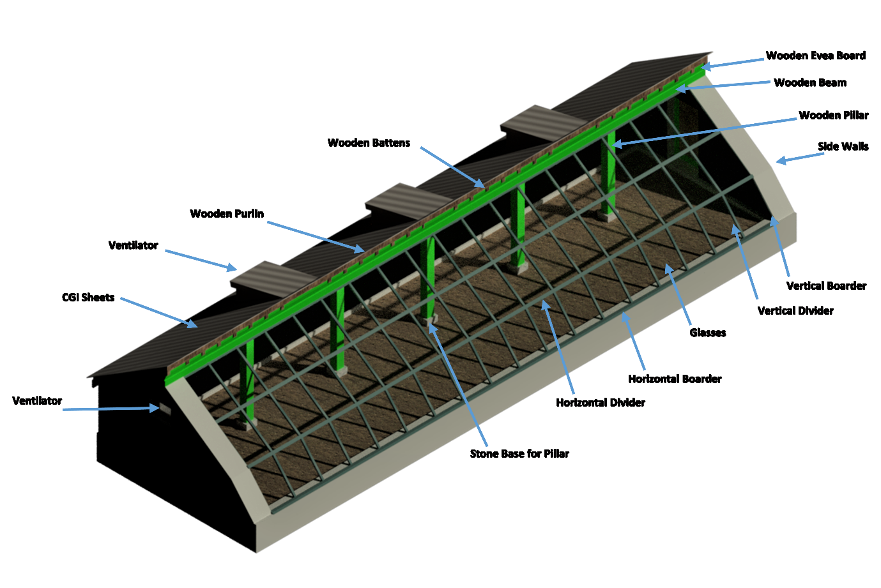

Cross-Section of Greenhouse
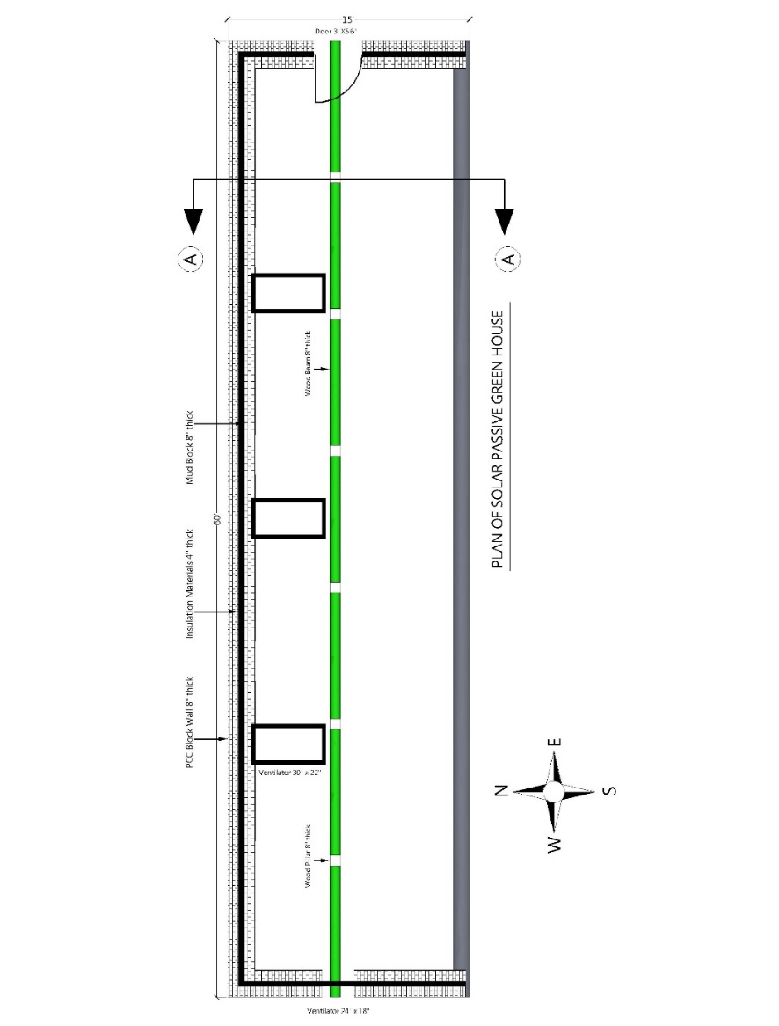
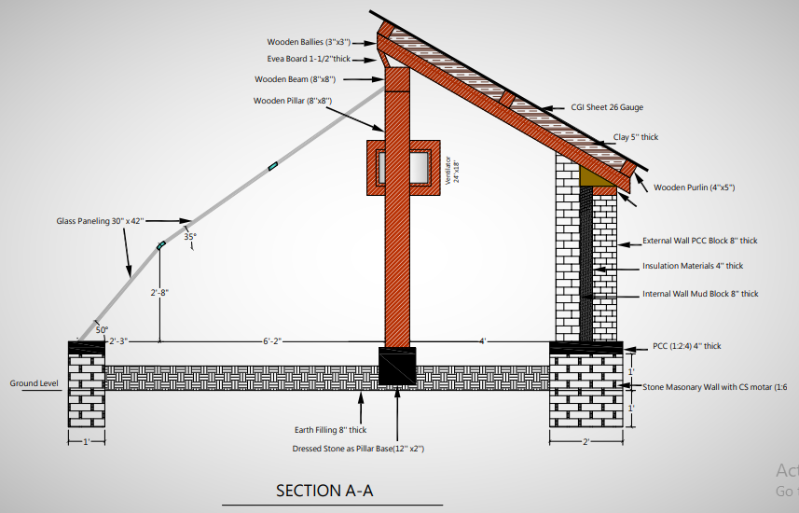

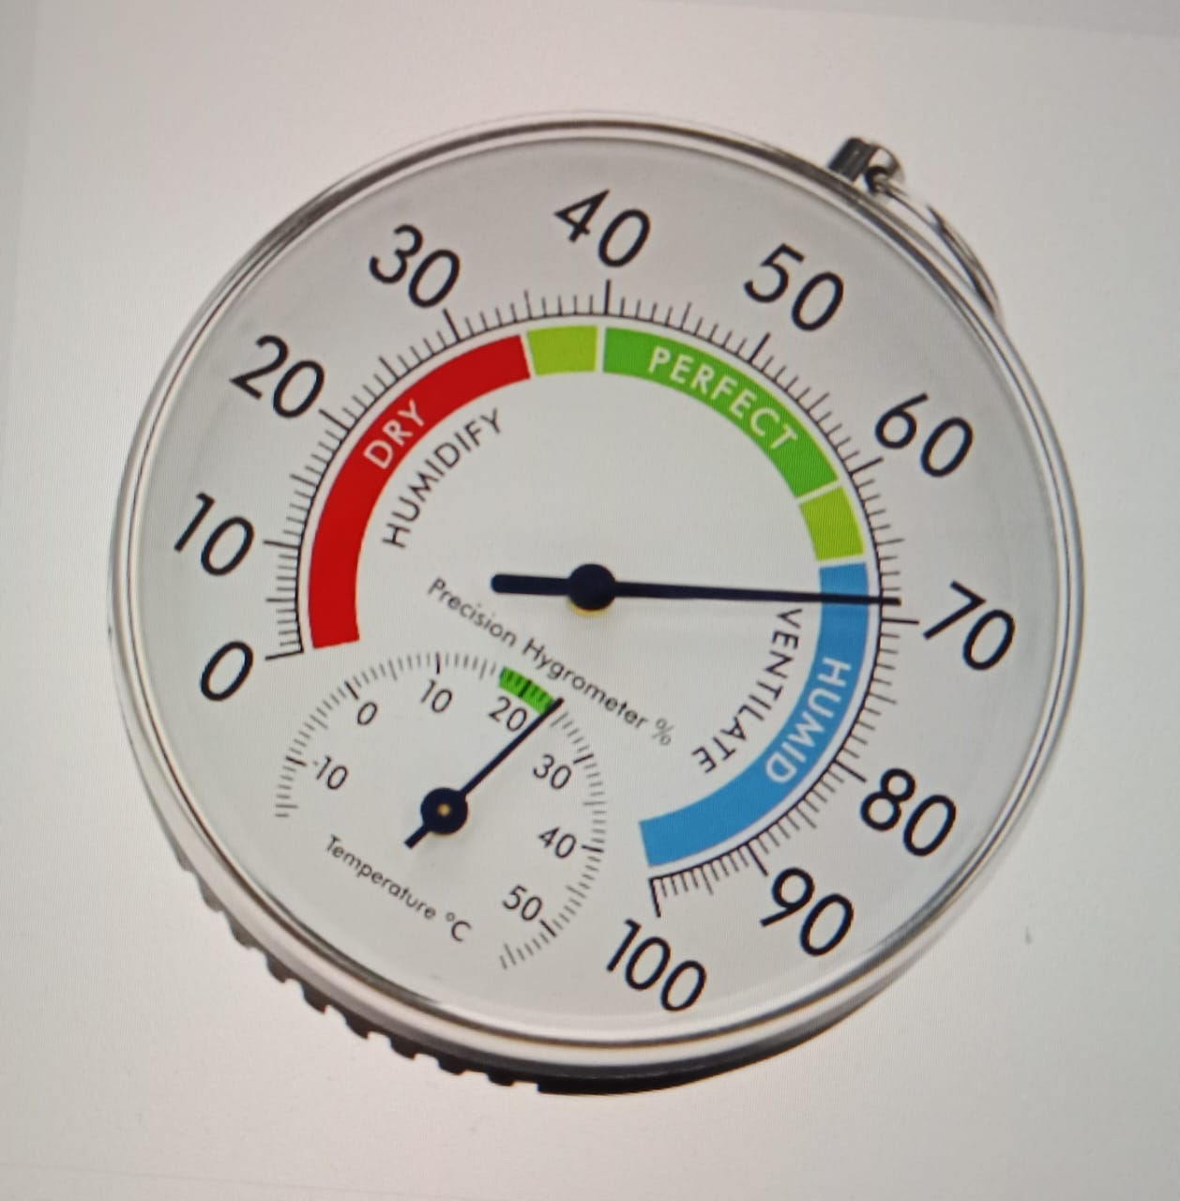
Picture of Thermometer/Hygrometer

