Aga Khan Rural Support Program (AKRSP)

REQUEST FOR QUOTATION (RFQ)

RFQ No: AKRSP/336/2025 Delivery Point: Arkari & Yarkhoon

RFQ Date: August 22, 2025 Submission Date: September 07, 2025

Request for Quotation (RFQ)

**1. Introduction**

The Aga Khan Rural Support Programme (AKRSP) invites sealed quotations from qualified, reliable, and experienced vendors for the Supply, Transportation, and Installation of Aluminum Glasses, Corrugated Galvanized Iron (CGI) Sheets, and Thermopore Sheets for Passive Solar Greenhouse Projects at multiple locations across Upper and Lower Chitral.

This RFQ aims to solicit competitive quotations from vendors who can deliver high-quality materials, provide safe and timely transportation to challenging and remote terrains, and complete installation according to the approved design and technical standards of AKRSP.

The project contributes to climate-resilient livelihoods by enabling communities to grow vegetables and other crops throughout the year through passive solar greenhouses. Therefore, timely delivery, quality compliance, and durability of the supplied material are of paramount importance.

Vendors are advised to carefully study this document and submit comprehensive quotations in accordance with the requirements herein. Failure to comply with these terms and conditions may result in rejection of the quotation.

**2. Scope of Requirements**

The scope of work under this RFQ includes:

1. Supply of Materials
   * Aluminum profiles, glasses, CGI sheets, thermopore sheets, and accessories as per detailed BOQ.
   * Supply of ancillary items such as rubber packing, silicon, and thermometers / hygrometers.
2. Transportation
   * Safe loading, transportation, and delivery of materials to designated greenhouse sites located in various valleys of Upper and Lower Chitral.
   * Vendors are responsible for ensuring all safety measures during transportation to avoid damages.
3. Installation
   * Complete installation of aluminum frames and glass panels according to approved greenhouse design.
   * Fixing of CGI and thermopore sheets as per specifications.
   * Ensuring quality finishing, sealing, and insulation to achieve desired greenhouse performance.
4. Compliance with Design Standards
   * All works must strictly adhere to the approved design, safety standards, and environmental considerations.
5. Inspection & Handover
   * Materials and installation will be inspected by AKRSP’s technical team at Chitral and/or at the project sites.
   * Only after successful inspection and satisfactory completion will the handover be considered final.

**3. Bill of Quantities (BOQ)**

BOQ for one Passive Solar Greenhouse (Size: 60’ x 15’)

|  |  |  |  |  |  |  |
| --- | --- | --- | --- | --- | --- | --- |
| S. No. | Description | Specifications | Unit | Qty | Rate (Rs) | Amount (Rs) |
| 1 | Vertical Border | D54A 2mm | rft | 22.0 |  |  |
| 2 | Horizontal Border | D54 A 2mm | rft | 112.0 |  |  |
| 3 | Vertical Divider | D59 1.6mm | rft | 220.0 |  |  |
| 4 | Horizontal Divider | D59 1.6mm | rft | 112.0 |  |  |
| 5 | Supporting Pipe | 2''x1'' | rft | 100.0 |  |  |
| 6 | Bedding | D41 | rft | 630.0 |  |  |
| 7 | Angle | 1.5”x1.5” size, thickness 3mm | rft | 24 |  |  |
| 8 | Glasses | Thickness=5mm; Length=3.5 ft; Width=2.5 ft; Qty=70 | sft | 612.50 |  |  |
| 9 | Rubber Packing | PVC Super Fix | rft | 630.0 |  |  |
| 10 | Silicon |  | No | 16.0 |  |  |
| 11 | Thermometer/Hygrometer | Analog indicator, indoor-outdoor, L15 | No | 1 |  |  |
| 12 | Installation Cost of Aluminum & Glasses | Lump Sum | No | 1 |  |  |
| 13 | Supply of CGI Sheets & Accessories | Gauge: 30; Thickness: 0.31 mm; Size: 9’x3.5’; Weight per sheet: 8 kg; Cup washers & nails: 5 kg | No | 19 |  |  |
| 14 | Supply of Thermopore Sheets | Size: 4’x4’; Thickness: 12mm; Color: white; TP D-24 | No | 24 |  |  |
| 15 | Transportation Cost | Average cost of transportation of all above items to project sites | No | 1 |  |  |
| Total |  |  |  |  |  |  |

**4. Locations of Greenhouses**

|  |  |  |
| --- | --- | --- |
| Location (Chitral Valleys) | Physical Target | Distance from Chitral (km) |
| Dewsar, Lower Yarkhoon, Upper Chitral | 01 | 150 |
| Sholkoch, Lower Yarkhoon, Upper Chitral | 01 | 150 |
| Pardan, Lower Yarkhoon, Upper Chitral | 01 | 140 |
| Miragram No. 2 Bala, Upper Chitral | 01 | 138 |
| Ovir Lasht, Arkari, Lower Chitral | 01 | 75 |

**5. Submission Requirements**

* Quotations must be prepared on the official letterhead of the company/organization.
* Each quotation must bear the date, signature, and official stamp of the authorized signatory.
* Vendors must attach a copy of their valid business registration, NTN certificate, and sales tax registration.
* Vendors must submit relevant past performance records showing experience in similar works.
* Quoted prices must be inclusive of all applicable taxes, duties, transportation, installation, and other related costs.
* Quotations must remain valid for a minimum of 30 days from the submission deadline.

**6. Terms and Conditions**

The following terms and conditions will govern the procurement process and contract execution. Vendors are strongly advised to carefully read and acknowledge these conditions in their quotation cover letter.

**6.1 General Provisions**

1. Non-Binding Nature
   * AKRSP is under no obligation to award a contract or accept the lowest bid.
   * AKRSP reserves the right to accept or reject any quotation without assigning reasons.
2. Right to Cancel
   * AKRSP reserves the right to cancel the procurement process at any stage if deemed necessary in the organization’s interest.
3. Validity of Quotation
   * Vendors must ensure their quoted rates remain valid for a minimum of 30 days from the date of submission.

**6.2 Compliance with Specifications**

1. Vendors must comply strictly with the technical specifications and BOQ.
2. AKRSP’s technical team will conduct inspection at Chitral or at project sites. Materials not conforming to specifications will be rejected at the vendor’s cost.
3. Replacement of rejected materials must be carried out within 10 working days of notification.

**6.3 Risk Management**

1. Vendors are responsible for all risks associated with transportation and installation until final handover.
2. Any damages caused to materials during loading, unloading, or transportation will be borne solely by the supplier.
3. Vendors must carry adequate insurance for materials in transit and during installation.

**6.4 Child Labor and Ethical Standards**

1. Vendors must ensure zero involvement of child labor in any stage of supply, transportation, or installation.
2. Vendors must uphold principles of ethical trade, fair wages, and safe working conditions.
3. Failure to comply may lead to immediate contract termination and blacklisting.

**6.5 Conflict of Interest**

1. Vendors must disclose any actual or potential conflicts of interest.
2. Submission of quotations under multiple company names by the same entity/individual is strictly prohibited and will result in blacklisting.

**6.6 Safety & Security**

1. Vendors must ensure that their staff complies with all safety and security protocols at sites.
2. Vendors must provide workers with appropriate Personal Protective Equipment (PPE).
3. Vendors are responsible for safe conduct of work without causing harm to communities, property, or the environment.

**6.7 Force Majeure**

1. Neither party shall be held liable for failure to perform obligations due to unforeseeable events beyond their control, such as natural disasters, strikes, wars, or government restrictions.
2. Vendors must notify AKRSP in writing within 5 working days of the occurrence of such an event.

**6.8 Penalties for Delay**

1. Completion of delivery and installation must be achieved within 45 days of contract signing.
2. Delays without valid justification will attract penalties at 0.5% of total contract value per day, up to a maximum of 10%.
3. Beyond this limit, AKRSP reserves the right to terminate the contract.

**6.9 Dispute Resolution**

1. Any disputes arising under this RFQ or subsequent contract shall first be attempted to resolve amicably through negotiations.
2. If unresolved, disputes shall be referred to arbitration under the Arbitration Act of Pakistan, 1940.
3. The venue of arbitration shall be Chitral, and proceedings shall be conducted in Urdu/English.

**7. Evaluation Criteria**

Quotations will be evaluated using the following criteria:

1. Technical Compliance – adherence to specifications and BOQ.
2. Financial Assessment – lowest evaluated price will be considered, provided compliance is met.
3. Past Experience – proven capacity and track record in similar projects.
4. Delivery Commitment – ability to deliver within stipulated 45 days.

The contract will be awarded to the lowest evaluated bidder meeting all requirements.

**8. Payment Terms**

* 50% upon delivery of materials to Chitral, after inspection.
* 40% upon delivery of all materials to work sites.
* 10% upon successful completion of installation and final inspection.

**9. Taxes**

Quoted prices must be inclusive of all applicable taxes and duties.

**10. Acknowledgement**

All vendors must sign and return the acknowledgment slip confirming receipt and acceptance of RFQ terms.

Admin & Procurement Officer Vendor Receipt & Acknowledgement

AKRSP Name: _________________________ Designation: _____________________

Sign & Stamp

Description of Works: Supply, Transportation & Installation of Aluminum & Glasses in Greenhouse

and Supply of CGI Sheets & Thermopore Sheets in various valleys of Chitral.

BOQ for one Greenhouse of (60’x15’) Size

|  |  |  |  |  |  |  |
| --- | --- | --- | --- | --- | --- | --- |
| S. No. | Description | Specifications | Unit | Qty | Rate (Rs) | Amount (Rs) |
| 1 | Vertical Border | D54A 2mm | rft | 22.0 |  |  |
| 2 | Horizontal Border | D54 A 2mm | rft | 112.0 |  |  |
| 3 | Vertical Divider | D59 1.6mm | rft | 220.0 |  |  |
| 4 | Horizontal Divider | D59 1.6mm | rft | 112.0 |  |  |
| 5 | Supporting Pipe | 2''x1'' | rft | 100.0 |  |  |
| 6 | Bedding | D41 | rft | 630.0 |  |  |
| 7 | Angle | 1.5”x1.5” size thickness 3mm | rft | 24 |  |  |
| 8 | Glasses | Thickness=5mm Length=3.5-ft, width=2.5-ft Total No=70 | sft | 612.50 |  |  |
| 9 | Rubber Packing | PVC Super fix | rft | 630.0 |  |  |
| 10 | Silicon |  | No | 16.0 |  |  |
| 11 | Thermometer/Hygrometer | Analog indicator indoor outdoor thermometer Hygrometer L15 | No | 1 |  |  |
| 12 | Installation Cost of Aluminum & Glasses Only | Lumpsum | No | 1 |  |  |
| 13 | Supply of CGI Sheets and accessories | Gauge: 30, Thickness: 0.31 mm, Size: 9’x3.5’  Weight per sheet: 8 kg  Cup washers and nails: 5 kg | No | 19 |  |  |
| 14 | Supply of Thermopore Sheets | Size: 4’x4’, Thickness: 12 mm, Color: white, TP D-24 | No | 24 |  |  |
| 13 | Transportation Cost of all items listed above to the below mentioned locations | Average cost | No | 1 |  |  |
|  | Total Amount |  |  |  |  |  |

Locations of 60’x15’ size Greenhouses

|  |  |  |
| --- | --- | --- |
| Chitral Valleys | Physical Targets | Distance from Chitral (km) |
| Dewsar, Lower Yarkhoon, Upper Chitral | 01 | 150 |
| Sholkoch, Lower Yarkhoon, Upper Chitral | 01 | 150 |
| Pardan, Lower Yarkhoon, Upper Chitral | 01 | 140 |
| Miragram, No.2 Bala, Upper Chitral | 01 | 138 |
| Ovir Lasht, Arkari, Lower Chitral | 01 | 75 |

Diagrams of 60’x15’ size Greenhouse

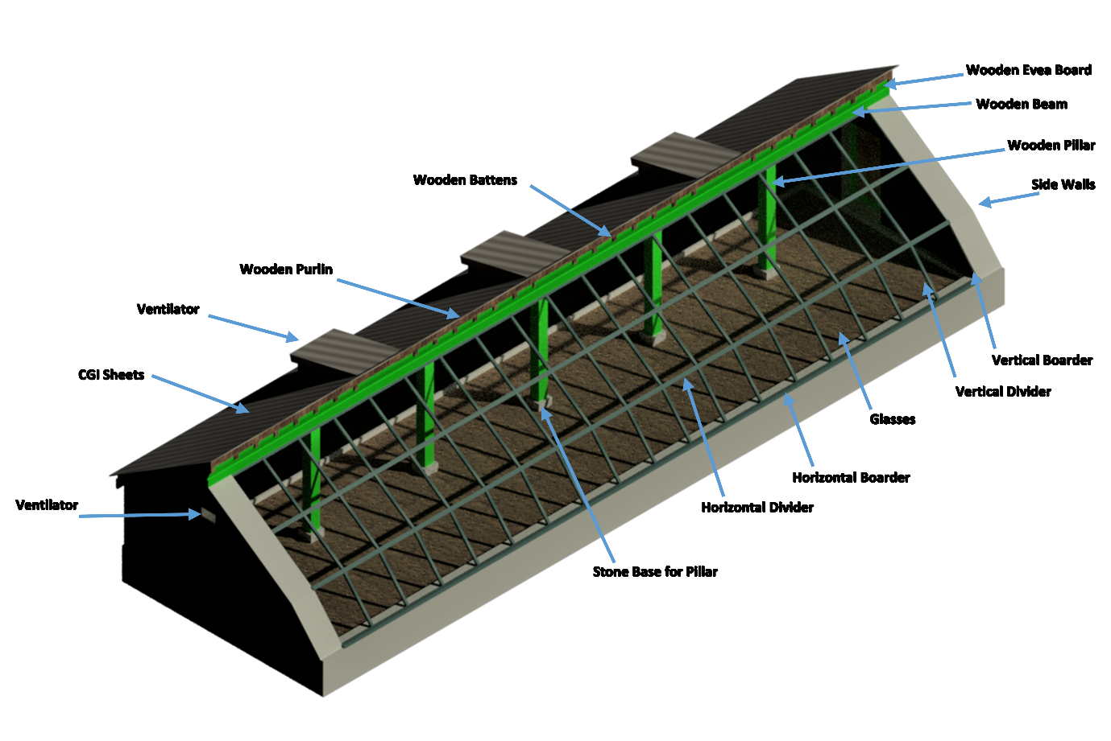

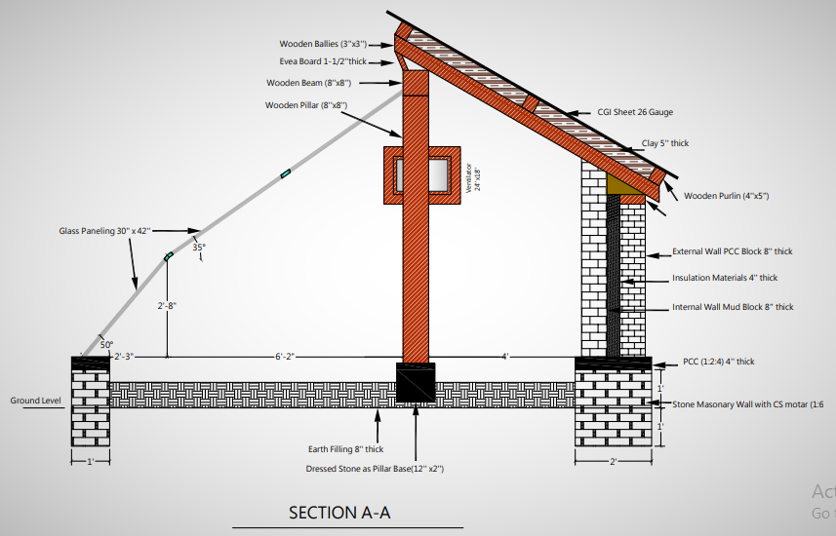

Picture of Thermometer/Hygrometer

